ASSIUT UNIVERSITY
Faculty of Commerce
Public Policy Information Systems Program

GRADUATION PROJECT REPORT

Project Title:
DOCBOT

Academic Year | 2025/2026
Semester | Second semster
Program | Public Policy Information Systems
Supervisor | Prof. Ahmed El-Shoura Abou-Zeid
Supervisor | Prof. Abdel-Rahman Hedar
Submission Date | 27 June 2026

Project Team Members

# | Student Name | Student ID | Specialization | Role in Project
1 | Rania Diaa Mohamed |  | PPIS | Leader/ Backend Developer
2 | Rwan Osama Youssef | 2209058 | PPIS | ERD Developer
3 | Rowan Mostafa Kamal | 2209059 | PPIS | Frontend Designer
4 | Fatma Nasser Sayed | 2209095 | PPIS | Frontend Designer
5 | Caroline Maged Filib | 2209097 | PPIS | Backend Designer
6 | Sohyla Ahmed Mahmoud | 2209072 | PPIS | Frontend Designer
7 | Fatma El-Zahraa Ashraf | 2209096 | PPIS | Backend Developer
8 | Mai Kamel |  | PPIS | ERD Developer
9 | Ahmed Hamdy Samir | 2209006 |  | AI Specialist
10 | Motaaz Naser |  | PPIS | Backend Developer
11 | Yehia | 2209092 | PPIS | AI Specialist

Declaration of Originality
We, the undersigned members of the graduation project team, hereby declare that:
- This report and the accompanying software system represent our own original work.
- All sources of information, whether text, diagrams, code libraries, or frameworks, have been duly cited and acknowledged.
- No part of this project has been submitted previously for any academic qualification at this or any other institution.
- The software developed does not infringe any intellectual property rights.
Signed:
Student Name | Signature | Date
Rania Diaa Mohamed
Rwan Osama Yossef
Rawon Mostafa Kamal
Fatama Nasser Sayed
Fatma El-Zahraa Asharf
Caroline Maged Filib
Sohyla Ahmed Mahmoud
Mai Kamel
Ahmed Hamdy Samir
Motaaz Nasser
Yehia

Supervisor Approval
I confirm that this graduation project report meets the requirements of the department and is approved for submission.
Supervisor Name: ____________________________
Signature: ___________________ Date: __________________

Abstract

The problem –
Objectives –
Methodology –
Technologies –
Main Features –
Results & Conclusions –

Acknowledgements

Table of Contents

Declaration of Originality 2
Abstract 3
Acknowledgements 4
Table of Contents 4
List of Figures 5
List of Tables 5
List of Abbreviations 5
1. Introduction 6
1.1 Background and Motivation 6
1.2 Problem Statement 6
1.3 Project Objectives 7
1.4 Project Scope 7
1.5 Target Users and Beneficiaries 9
B. The Physician: Seeking Structured Data & Time-Saving 10
1.6 Report Structure 10
2. Literature Review 11
2.1 Overview of the Problem Domain 11
2.2 Review of Related Systems and Research 12
Technologies Used 16
Findings 16
Limitations 16
Description 17
Technologies Used 17
Findings 17
Limitations 17
Description 18
Technologies Used 18
Findings 18
Limitations 18
2.2.8 AI-Driven Clinical Decision Support Systems: An Ongoing Pursuit of Potential 19
Description 19
Technologies Used 19
Findings 19
Limitations 19
2.3 Comparison of Related Systems 20
2.4 Research Gaps and Justification 20
3. Requirements Analysis 21
3.1 Requirements Elicitation Methodology 21
3.2 Stakeholder Analysis 21
3.3 Functional Requirements 22
3.4 Non Functional Requirements 23
3.4.1 Usability 23
3.4.2 Security and Data Privacy 24
3.4.3 Compatibility 24
3.4.4 History Filtering & Visualization 24
3.4.5 Diagnosis Support 24
3.5 Use Cases Diagrams 25
3.5.1 Patient Login & Start Consultation 25
3.5.5 UC-05: Medication Reminder & Adherence Tracking 30
3.6.4 UC-04: Doctor Review & Prescription 36
Figure 4.2.1.6: Entity Relationship Diagram (ERD) for Medication Reminder and Notification Management Subsystem 46
4.2.2.1 User Table 48
5.6 System Screenshots 74
5.7 Challenges Encountered and Solutions 80
6. Testing and Evaluation 80
6.1 Testing Strategy 81
6.2 Types of Testing Performed 81
6.2.1 Unit Testing 81
6.2.2 Integration Testing 81
6.2.3 System Testing 81
6.2.4 User Acceptance Testing (UAT) 81
6.2.5 Performance Testing 81
6.3 Test Cases and Results 81
6.4 Test Summary 81
6.5 Evaluation Against Requirements 81
6.6 Limitations and Known Issues 81
7. Conclusion and Future Work 81
7.1 Summary of Work Done 81
7.2 Key Findings and Lessons Learned 82
7.3 Comparison with Objectives 82
7.4 Future Work and Recommendations 83
7.5 Closing Statement 84
Appendix J: Detailed Feasibility Study Report 88
2. TECHNICAL FEASIBILITY 88
3. ECONOMIC FEASIBILITY 89
3.1 Capital Expenditure (CAPEX) - Team Labor Value 89
3.2 Monthly Operational Expenditure (OPEX) & Gradual Scaling Strategy: 90
3.3. Commercial Gradual Scaling & Revenue Forecasting (Years 1–3): 93
3.3.1Financial Sensitivity Analysis & Market Scenarios 94
4.Investment Valuation Metrics: 96
4.1 Net Present Value (NPV) 96
Appendix D: User Manual: 113
D.1 Introduction 114
D.2 System Access and Setup 114
D.2.1 Web Application Access 114
D.2.2 Account Creation (Patients) 114
D.2.3 Doctor Access (Providers) 114
D.3 System Features and Usage 114
D.3.1 AI Chatbot Assistant (Patient Intake) 115
D.3.2 Viewing Medical History 115
D.3.3 Specialty Recommendation 115
D.3.5 Medication Management 116
D.3.6 Lab Results Integration 116
D.4 System Configuration (Admin – Optional Section) 116
D.6 Security and Privacy 117
D.7 Notes for Users 118

List of Figures

List of Tables

List of Abbreviations

Abbreviation | Full Form
AI | Artificial Intelligence
API | Application Programming Interface
BMC | Business Model Canvas
DBMS | Database Management System
EHR | Electronic Health Record
ERD | Entity Relationship Diagram
FRS | Functional Requirements Specification
GCP | Good Clinical Practice
JSON | JavaScript Object Notation
MVC | Model-View-Controller
ORM | Object-Relational Mapping
SAAS | Software as a Service
SDLC | Software Development Life Cycle
SRS | Software Requirements Specification
UAT | User Acceptance Testing
UI | User Interface
UML | Unified Modeling Language
UX | User Experience
WBS | Work Breakdown Structure

CHAPTER 1

Introduction

1.1 Background and Motivation
The healthcare sector is a fundamental pillar of national security, yet it faces critical structural challenges, including soaring operational costs and a projected global workforce shortage of 10 million by 2030 (World Health Organization, 2016). In Egypt, this crisis is intensified by a fragmented data ecosystem where providers largely depend on paper-based records, leading to the loss of up to 40% of critical patient data (General Authority for Healthcare Accreditation and Regulation, n.d.). This fragmentation results in misinformed clinical decisions, repeated diagnostics, and an inefficient patient journey, where out-of-pocket spending constitutes approximately 60% of current health expenditure (The World Bank, 2021).
The motivation behind DocBot is to transition from a "reactive" treatment model to a "proactive" digital ecosystem (Aijazuddin, 2024). By aligning with Egypt’s Vision 2030 and the National Digital Health Strategy (2025-2029), DocBot aims to bridge the "execution gap" in healthcare digitization (Alorbany et al., 2025; State Information Service, 2024). The project is driven by the need for an intelligent "pre-consultation assistant" that unifies isolated data silos into a cohesive, cloud-based Electronic Health Record (EHR) (Alkhatlan, 2019; Wang et al., 2018). This transformation is not merely a technological upgrade but a strategic necessity to enhance diagnostic accuracy, reduce financial waste, and ensure health equity across urban and rural populations (Alzhrani et al., 2024).

1.2 Problem Statement
Despite national efforts toward digital transformation, the Egyptian healthcare landscape suffers from a critical absence of automated clinical intake tools capable of bridging the gap between patient history and clinical decision-making (Alorbany et al., 2025). Currently, patients must rely on their memory during consultations because their medical information remains scattered across disconnected systems (Stroetmann, 2009). This lack of standardized, structured reporting leads to several key issues:
- Clinical Risks: Fragmented records directly increase the risk of preventable medical errors and treatment delays (Stroetmann, 2009).
- Operational Inefficiency: Physicians face administrative burdens and burnout due to manual data entry and redundant medical testing (Auld, 2024).
- Economic Waste: Patients frequently repeat expensive diagnostic tests and receive conflicting prescriptions due to the lack of a reliable, unified medical history (The World Bank, 2021).
- Diagnostic Accuracy Gap: Existing foreign symptom-checkers often lack the contextual nuance required for local clinical protocols, achieving significantly lower accuracy compared to specialists (Alorbany et al., 2025).
DocBot addresses this problem by implementing a logic-based AI engine that performs intelligent history taking, symptom processing, and smart routing, ensuring that every patient arrives at the clinic with a detailed, timeline-based medical record (Alorbany et al., 2025).

1.3 Project Objectives
This project aims to achieve the following objectives:
- Develop a fully functional AI-driven ecosystem to unify fragmented patient data and provide automated clinical intake.
- Implement an Intelligent Triage Chatbot to address the gap in standardized history-taking and minimize human error through structured, branching question formats.
- Design a user-friendly interface that meets the needs of both patients and internal medicine specialists, prioritizing "at-a-glance" information for clinical efficiency.
- Ensure system reliability and safety through rigorous testing of triage logic to minimize "under-triage" risks and ensure high-risk cases are identified early.
- Apply all phases of the Software Development Life Cycle (SDLC) in a professional manner to deliver a scalable, "AI-ready" healthcare platform.

1.4 Project Scope
In-scope features and functionalities:

AI Chatbot Assistant (Patient-Facing): An intelligent interface that conducts initial interviews, utilizes branching logic based on symptoms, and identifies "Red Flags" for high-severity cases.

Comprehensive History Database: A centralized repository for storing chronic disease data (e.g., Diabetes, Hypertension), family medical history, and lifestyle factors.

Specialty Recommendation Engine: A logic-based module that automatically routes patients to the correct internal medicine sub-specialty based on their clinical assessment.

Dynamic Electronic Health Records (EHR) & Timeline: A provider-facing dashboard that displays a detailed, chronological medical record to enhance diagnostic accuracy.

Laboratory Data Integration: Automated synchronization and parsing of lab results via secure APIs to reduce redundant testing and administrative workload.
Medication Management & Tracking: An automated system for scheduling medication reminders and logging adherence status without altering core medical records.

Out-of-scope (future work):

Real-time IoT Remote Monitoring: Continuous 24/7 vital sign tracking via wearable devices and IoT sensors is excluded from the current phase due to infrastructure costs.

Fully Autonomous Diagnostic Model (Version 2.0): The transition from "provisional suggestions" to an advanced diagnostic model will only occur after collecting a sufficient volume of verified clinical data.

Cross-Institutional Financial Settlement: Integration with national insurance payment gateways or universal health insurance billing systems.

1.5 Target Users and Beneficiaries
The DocBot ecosystem is designed to bridge the gap between two primary users, each interacting with the system to fulfill a specific clinical need:

A. The Patient: Seeking Clarity & Efficiency
Persona: Young to middle-aged adults (22–40 years), including university students and tech-savvy professionals.
User Motivation: Driven by a need for fast, convenient healthcare access and a fear of wasting time in hospital waiting rooms or misinterpreting symptoms through generic online searches.
The User’s Goal: "I want to understand my symptoms quickly and manage my health journey without redundant paperwork or repetitive medical history explanations.
Interaction with DocBot:
- Initiates the AI Chatbot to translate vague symptoms into structured clinical data.
- Maintains a Unified Medical Timeline to ensure data continuity across different visits.
- Utilizes Medication Reminders to ensure adherence to treatment plans for chronic or acute conditions.

B. The Physician: Seeking Structured Data & Time-Saving

Persona: Residents, Specialists, and Consultants (28–50 years) within Internal Medicine sub-specialties.
User Motivation: Driven by the desire to organize patient data and reduce administrative burdens; fears complicated or slow systems that might cause data loss.
The User’s Goal: "I need an organized, 'at-a-glance' summary of the patient’s history and risk factors before the consultation begins to improve diagnostic accuracy."
Interaction with DocBot:
- Accesses the Provider Dashboard to review summarized clinical intake and AI-generated triage reports.
- Prioritizes urgent cases by filtering patients based on Specialty & Severity (Red Flags).
- Reviews Integrated Digital Lab Reports and history to monitor patient progress over time efficiently.


1.6 Report Structure
This documentation is systematically organized into seven interrelated chapters, designed to mirror the progressive stages of the Software Development Life Cycle (SDLC) executed for the DocBot platform:

Chapter 1 — Introduction: Establishes the foundational background of the Egyptian medical ecosystem, formulates the core problem statement regarding fragmented health records, outlines the definitive project objectives, defines the scope boundaries, and presents the structural overview of this report.

Chapter 2 — Literature Review: Conducts a comprehensive clinical and technical scan of existing Electronic Health Record (EHR) systems and AI triage platforms, analyzing their core structural strengths and functional execution gaps to highlight the competitive advantages of DocBot.

Chapter 3 — Requirements Analysis: Formulates the comprehensive software requirements gathered from clinical interviews and stakeholder data elicitation, defining the functional modules (such as automated client intake and chronological medical timelines) and non-functional engineering metrics (security, data privacy, and availability).

Chapter 4 — System Design: Details the structural and architectural design patterns of the platform, including unified object-oriented UML models (Class and Sequence diagrams), the relational database schema design (ERD layouts), and the responsive "at-a-glance" user interface wireframes optimized for internal medicine specialists.

Chapter 5 — Implementation: Illustrates the concrete environment configurations, tech stacks, and development methodologies utilized during construction, specifically focusing on the deployment of the Django backend framework, MySQL data structures, the n8n workflow automation orchestration engine, and the DeepSeek-V4-Flash artificial intelligence model integration.

Chapter 6 — Testing and Evaluation: Outlines the rigorous quality assurance methodologies, component test cases, data privacy validation, and User Acceptance Testing (UAT) benchmarks executed to guarantee full system stability, accuracy, and operational reliability.

Chapter 7 — Conclusion and Future Work: Summarizes the architectural milestones achieved throughout the engineering cycle, provides a comprehensive project schedule matrix mapped against baseline deployment objectives, and proposes scalable technological enhancements for future operational horizons.

CHAPTER 2

Literature Review

2.1 Overview of the Problem Domain
The contemporary Egyptian healthcare ecosystem stands at a critical juncture, characterized by deep-rooted data fragmentation and operational silos (Stroetmann, 2009). Under the current clinical reality, patient medical histories, clinical diagnostics, and prescription logs are scattered across non-standardized paper-based systems, isolated spreadsheets, and disconnected departmental databases (Stroetmann, 2009). This structural disintegration creates immense "data silos," forcing patients to rely entirely on subjective memory to recount complex medical timelines during consultations (Stroetmann, 2009).
Consequently, the absence of an interoperable national infrastructure creates high clinical and financial vulnerabilities, where out-of-pocket expenditure heavily burdens the health spending landscape (The World Bank, 2021). Clinicians are routinely forced to make diagnostic decisions based on incomplete historical logs, which exponentially elevates the risk of preventable medical errors and compromises patient safety (Stroetmann, 2009). Empirical research in localized clinical environments highlights that structured record utilization has a strong positive correlation with the improvement of overall patient safety and healthcare quality (Alkhatlan, 2019). Furthermore, data silos heavily trigger operational inefficiencies, leading to high rates of redundant, duplicated laboratory testing and fragmented continuity of care (Stroetmann, 2009). To mitigate these systemic gaps and achieve the core mandates of Egypt's National Digital Health Strategy (2025–2029), there is a critical necessity to analyze the technical and behavioral landscapes required to transition from static, disjointed medical environments toward unified, structured, and interoperable digital health data standards (State Information Service, 2024).

2.2 Review of Related Systems and Research
2.2.1 Esaal:
Esaal is a digital healthcare consultation platform that provides patients with on-demand access to certified physicians across multiple specialties, including internal medicine, mental health, and nutrition. The platform aims to improve healthcare accessibility by enabling remote medical consultations through various communication channels such as text messaging, voice calls, and video consultations (Esaal, n.d.).
The platform is built on telemedicine infrastructure and integrates artificial intelligence technologies through an AI-powered chatbot. This chatbot interacts with patients to collect and analyze reported symptoms, such as severity, location, and associated conditions, with the goal of guiding the patient toward the appropriate medical specialty (Esaal, n.d.).
The platform’s key features include instant medical consultations, AI-assisted symptom data collection, and multi-channel communication with healthcare providers. It also supports a pre-consultation phase, during which patient information is collected before connecting them with a doctor (Esaal, n.d.).
Despite these capabilities, Esaal faces several limitations regarding clinical data management. The AI chatbot primarily focuses on extracting current symptoms and does not automatically collect a comprehensive medical history, such as previous surgeries, chronic diseases, or long-term patient health records. Additionally, historical medical information is often manually entered by patients through separate forms rather than being integrated into the interactive conversational flow.
Furthermore, the platform does not generate a unified, structured electronic medical record organized chronologically, combining real-time symptom data with the patient’s historical information for physician review. As a result, doctors may not receive a complete and integrated clinical profile prior to the consultation .
2.2.2 Altibbi :
Altibbi is one of the largest digital health platforms in the Arab region, aiming to provide remote medical consultation services through text and voice calls, in addition to offering comprehensive Arabic medical content that helps users better understand various health conditions in a simplified manner (Altibbi, n.d.).
The platform relies on artificial intelligence technologies through a chatbot designed to collect basic symptoms from users, such as age and the main complaint, in order to guide the patient to the appropriate physician via text messaging or voice calls. The platform also supports communication between patients and certified doctors through chat and voice calls, facilitating access to remote healthcare services (Altibbi, n.d.).
Its main features include providing instant medical consultations, delivering educational medical content, and using an intelligent chatbot to collect initial patient data and direct users to appropriate medical services (Altibbi, n.d.).
Altibbi leverages artificial intelligence and Natural Language Processing (NLP) to analyze user-input symptoms and support initial medical triage, in addition to a telemedicine infrastructure that enables remote communication between doctors and patients (Altibbi, n.d.).
Accordingly, the platform can be considered as providing basic support in patient guidance; however, it remains limited in terms of building a fully integrated clinical system for managing the patient journey.
Despite using AI for basic symptom collection, Altibbi is still closer to a traditional telemedicine consultation platform rather than an advanced clinical decision-support system. It lacks an integrated clinical workflow that combines detailed symptom analysis, risk assessment, and an interactive booking journey. In addition, its electronic health record (EHR) system is limited and does not provide a structured, long-term chronological record of patient data that can be reliably used in clinical practice.
2.2.3 Vezeeta :
Vezeeta is one of the leading digital healthcare platforms in Egypt and the Middle East, aiming to facilitate patient access to healthcare providers through an integrated electronic system for booking medical appointments, exploring doctors based on specialty, location, and ratings, as well as offering telemedicine services and pharmacy-related services (Vezeeta, n.d.).
The platform relies on cloud-based booking system technologies and large-scale databases of healthcare providers, enabling efficient organization of communication between patients and physicians. It is also built on a digital infrastructure that aggregates provider data and presents it in a way that helps users make informed medical booking decisions (Vezeeta, n.d.).
Its key features include providing a comprehensive medical directory of doctors, an electronic appointment booking system, telemedicine consultation services, and access to pharmacy and medication delivery services. The platform also offers a user-friendly interface that allows patients to search for and compare doctors before booking appointments (Vezeeta, n.d.).
Vezeeta demonstrates strong performance in organizing access to healthcare services and connecting patients with physicians; however, it does not provide intelligent clinical support or preliminary medical analysis prior to booking, making its primary role administrative and organizational rather than clinical.
Nevertheless, Vezeeta primarily operates as a commercial medical directory and scheduling platform. It lacks automated clinical intelligence, as there is no AI-based symptom analysis, no intelligent patient triage mechanism, and no integrated system for capturing medical history in advance. Furthermore, it does not provide a unified electronic health record (EHR) system, which results in patients having to repeatedly explain their medical history at each visit without access to structured or continuous clinical data.
2.2.4 HealthTag :

HealthTag is a digital healthcare platform that enables users to book doctor appointments, schedule laboratory tests, and order medications online through a mobile application. The platform aims to improve healthcare affordability by providing discounted healthcare services through a Family Subscription Card that covers the primary user and up to four family members (HealthTag, n.d.).
The platform is accessible through a mobile application and includes a digital health record module. However, this module functions primarily as a basic data repository that stores personal information, emergency contact details, blood type, uploaded prescription images, and a limited number of chronic disease records (HealthTag, n.d.).
The platform’s key features include online doctor appointment booking, laboratory test scheduling, medication ordering, access to discounted healthcare services through the Family Subscription Card, and basic patient health record storage (HealthTag, n.d.).
The platform provides a unified channel for accessing healthcare services and helps users reduce healthcare expenses through its family subscription model (HealthTag, n.d.).
Despite these capabilities, HealthTag faces several limitations regarding clinical data management. The available health record is limited in scope and does not support structured medical history collection, automated symptom assessment, or intelligent patient interaction through an AI-powered chatbot.
Additionally, the platform cannot collect real-time symptom information or guide patients through an interactive clinical intake process.
Furthermore, the platform does not generate a comprehensive, chronologically organized Electronic Health Record (EHR) that combines current symptoms with the patient's historical medical information. As a result, healthcare providers may not have access to a complete and integrated clinical profile prior to patient consultations.
2.2.5 AI-Driven Electronic Health Records System for Enhancing Patient Data Management and Diagnostic Support in Egypt :
Alorbany et al. (2025) proposed an AI-driven Electronic Health Record (EHR) system designed to improve patient data management and support medical diagnosis in Egypt. The system aims to centralize patient information, reduce fragmentation of health records, and assist physicians in making more informed clinical decisions. The proposed solution integrates artificial intelligence techniques with electronic health records to organize patient data and provide diagnostic support based on available clinical information. The study highlights the potential of AI-powered EHR systems to improve healthcare efficiency, data accessibility, and clinical decision-making (Alorbany et al., 2025).

Technologies Used
- Electronic Health Records (EHR)
- Artificial Intelligence (AI)
- Clinical Decision Support
- Digital Health Infrastructure

Findings
The study found that integrating AI with EHR systems can improve patient data management, facilitate diagnostic support, and enhance healthcare service delivery by providing physicians with structured patient information (Alorbany et al., 2025).

Limitations
Although the proposed system improves data management and diagnostic support, it does not focus on interactive symptom collection through conversational AI, remote patient monitoring, or integrating laboratory, appointment, and medication services within a single patient-centered platform, which are core requirements of the proposed project.
2.2.6 AI in Remote Patient Monitoring: Technology & Applications
Laurent (2025) discusses the role of artificial intelligence in Remote Patient Monitoring (RPM). The study explores how wearable devices and connected sensors continuously collect patient health data and use AI algorithms to detect abnormalities, predict health risks, and support early intervention. The primary goal is to improve healthcare outcomes through continuous monitoring outside healthcare facilities (Laurent, 2025).

Technologies Used
- Artificial Intelligence
- Internet of Things (IoT)
- Wearable Sensors
- Predictive Analytics
- Remote Monitoring Systems

Findings
The study demonstrates that AI-powered monitoring systems can improve early disease detection, reduce hospital admissions, and enable proactive healthcare management (Laurent, 2025).

Limitations
The study focuses mainly on continuous monitoring after diagnosis rather than supporting the complete patient journey from symptom collection and medical history acquisition to consultation and electronic record generation.
2.2.7 AI-Enhanced Remote Patient Monitoring: Transforming Healthcare Delivery Through Predictive Analytics and Smart Technology
Prasad and Chaudhary (2025) examine how AI-enhanced remote patient monitoring systems utilize predictive analytics and smart technologies to monitor patient health and identify potential medical risks. The study emphasizes proactive healthcare delivery through continuous data collection and analysis (Prasad & Chaudhary, 2025).

Technologies Used
- Artificial Intelligence
- Predictive Analytics
- Smart Medical Devices
- Remote Patient Monitoring

Findings
The study found that predictive analytics can improve patient outcomes by identifying health deterioration before serious complications occur (Prasad & Chaudhary, 2025).

Limitations
The proposed approach focuses on monitoring patients after enrollment in healthcare programs and does not address AI-based symptom assessment, medical history collection, appointment management, or comprehensive EHR generation.

2.2.8 AI-Driven Clinical Decision Support Systems: An Ongoing Pursuit of Potential
Elhaddad and Hamam (2024) review the evolution and applications of AI-driven Clinical Decision Support Systems (CDSS). The study explores how AI can assist healthcare professionals by analyzing medical data, identifying patterns, and providing recommendations for diagnosis and treatment planning (Elhaddad & Hamam, 2024).

Technologies Used
- Artificial Intelligence
- Machine Learning
- Clinical Decision Support Systems (CDSS)
- Healthcare Analytics

Findings
The study concludes that AI-based CDSS can improve diagnostic accuracy and support evidence-based clinical decisions while reducing medical errors (Elhaddad & Hamam, 2024).

Limitations
The study focuses primarily on physician decision support and does not provide mechanisms for direct patient interaction, automated symptom collection, appointment scheduling, or integrated patient journey management.

2.3 Comparison of Related Systems

Feature | Altibbi | Esaal | Vezeeta | HealthTag | DocBot
AI Symptom Analysis | Partial | Yes | No | No | Yes
Intelligent Clinical Intake | Partial | Partial | No | No | Yes
Appointment Booking | Yes | Yes | Yes | Yes | Yes
Electronic Health Record (EHR) | Partial | Partial | No | Partial | Yes
Unified Healthcare Platform | Partial | Partial | Partial | Partial | Yes

2.4 Research Gaps and Justification
A profound "execution gap" persists in current digital health implementations; while institutional readiness is exceptionally high among Egyptian healthcare professionals (74%), routine clinical utilization remains stagnant at only 28% due to localized data fragmentation and complex, non-intuitive interfaces. Furthermore, existing regional deployments lack an automated, unified framework that seamlessly connects patient-side intake, background workflow automation, and physician-side decision support into a single data stream.
The proposed DocBot platform directly addresses these critical research gaps. By pairing a patient-facing, NLP-powered AI triage chatbot with a secure Django-backend and a unified MySQL EHR database, DocBot captures structured clinical history (Symptom, Duration, Urgency) prior to the physical consultation. This data is instantly injected into the doctor's dashboard alongside real-time laboratory data integrations, completely eliminating manual entry errors, reducing out-of-pocket costs from duplicate testing, and lowering the physician’s cognitive workload. Thus, DocBot transforms the clinical process from reactive documentation to automated, proactive, and equitable healthcare delivery.

CHAPTER 3

Requirements Analysis

3.1 Requirements Elicitation Methodology
To ensure the DocBot system meets the actual needs of both patients and healthcare providers, a variety of requirements elicitation techniques were employed. The process focused on gathering technical, functional, and domain-specific insights through the following methods:
- Semi-Structured Interviews: Extensive interviews were conducted with internal medicine physicians and domain experts to understand the clinical logic required for "Intelligent History Taking". These sessions helped define how the system should analyze symptom severity and route patients to the correct sub-specialties.
- Surveys and Questionnaires: Digital surveys were distributed among potential users, specifically university students and young professionals (aged 22–40), to identify their pain points regarding traditional healthcare waiting times and their readiness to use AI-driven triage tools.
- Document Analysis: A thorough review of academic papers, national health strategies (such as Egypt Vision 2030), and WHO reports was conducted. This analysis provided the statistical foundation for understanding health data fragmentation in Egypt and the economic impact of redundant medical testing.
- Consultations with Academic Supervisors: Regular meetings were held with university staff and project supervisors to refine the system’s scope and ensure that all technical implementations align with professional Software Development Life Cycle (SDLC) standards.
- Competitor Analysis: Analysis of existing platforms like Vezeeta, Altibbi, and Yodawy was performed to identify functional gaps, such as the lack of automated clinical intake and unified EHR timelines.

3.2 Stakeholder Analysis
Insert caption

Stakeholder | Role | Key Interest/ Expectations
Patient (End User) | Primary System User | Fast and convenient healthcare access with an easy-to-use digital interface. Expectations include accurate AI triage and secure, unified medical history tracking.
Physician (Doctor) | Clinical Decision Maker | Efficient organization of patient data to reduce administrative paperwork and manual history taking. Expectations include structured pre-consultation reports and AI-driven risk alerts.
Project Team | System Developers | Designing, implementing, and deploying the AI ecosystem following the Software Development Life Cycle (SDLC). Interests include technical scalability and system reliability.
Supervisors / Academic Staff | Academic Advisors | Monitoring the correct application of engineering standards and academic documentation. Expectations include a high-quality software product and a comprehensive research paper.
Diagnostic Laboratories | Data Partners | Seamless digital integration via secure APIs to deliver lab results directly to providers. Expectations include standardized data exchange and reduced data synchronization latency.
IT Support & Security Team | Technical Support | Maintaining system uptime (24/7 availability) and ensuring end-to-end encryption for sensitive health data. Interests include system maintainability and protecting against data breaches.

3.3 Functional Requirements

ID | Requirement Description | Priority | Category
FR-1 | The system shall allow users to register and create a new account. | High | User Management
FR-2 | The system shall authenticate registered users via username and password. | High | Security
FR-3 | The system shall allow administrators to manage user accounts (create, edit, delete). | High | Administration
FR-4 | The system shall conduct an AI-driven primary patient interview to collect and process symptoms and medical history. | High | Core Function
FR-5 | The system shall maintain a unified Electronic Health Record (EHR) for each patient to store lifelong medical data and history. | High | Core Function
FR-6 | The system shall provide a secure backend to store, manage, and retrieve patient info, doctor schedules, and historical records. | High | Database Management
FR-7 | The system shall analyze symptom severity and recommend the appropriate medical sub-specialty for the patient. | High | Core Function
FR-8 | The system shall allow patients to book and manage appointments with recommended specialists after the assessment. | Medium | Booking System
FR-9 | The system shall send automated notifications and reminders for medication timings and follow-up updates. | Medium | Communication

3.4 Non Functional Requirements

3.4.1 Usability
The user interface shall be intuitive; a new user of any age or technical skill level should be able to perform core tasks within 10 minutes without training.

3.4.2 Security and Data Privacy
- The system shall ensure that all medical data (EHR) is encrypted both at rest and during transmission.
- The system shall enforce strict access control, ensuring medical records are accessible only to authorized personnel, specifically the patient and their assigned doctor.

3.4.3 Compatibility
- The platform must be fully responsive and usable across various screen sizes, including mobile, tablet, and desktop devices.
- The system shall be accessible via major web browsers (Chrome, Firefox, Edge).

3.4.4 History Filtering & Visualization
- The system shall provide doctors with the ability to filter through extensive medical records efficiently.
- The system shall visualize the patient’s medical history in a detailed, chronological timeline format.

3.4.5 Diagnosis Support
- The system shall provide doctors with pre-populated lists of potential diagnoses based on the clinical history gathered by the AI chatbot.
- The diagnostic support tool should present outcomes as "provisional suggestions" to assist rather than replace the physician's judgment.

3.5 Use Cases Diagrams

3.5.1 Patient Login & Start Consultation

Figure 3.1: Activity Diagram for Patient Login Process
3.5.2 UC-02: Chatbot Symptoms Assessment

Figure 3.2: Sequence Diagram for Chatbot Symptoms Assessment Process

3.5.3 UC-03: Booking Appointment with Recommended Doctor

Figure 3.3: Activity Diagram for Patient Login Process

3.5.4 UC-04: Doctor Review & Prescription

Figure 3.4: Activity Diagram for Doctor Review and Prescription Process

3.5.5 UC-05: Medication Reminder & Adherence Tracking

Figure 3.5: Sequence Diagram for Medication Reminder and Adherence Process

3.6 Use Case Descriptions
3.6.1 Use Case: [UC-01–Patient Login & Start Consultation]
This use case describes the process where a pre-registered patient logs into the system using valid credentials. After successful authentication, the system grants access to the patient’s account and initiates a chatbot consultation session. The objective is to ensure secure login and enable the patient to start the consultation process smoothly.
Attribute | Description
Use Case ID | UC-01
Use Case Name | Patient Login & Start Consultation
Primary Actor | Patient
Pre-conditions | 1. Patient has a registered account.  2. System is connected to the database.
Main Success Scenario | 1. Patient opens the system.  2. Patient enters login credentials.  3. System validates credentials against the database.  4. Patient accesses their personal account.  5. Patient initiates the chatbot interaction session.
Alternative Flows | A1: Invalid Credentials: If the system fails to validate the login data, it displays an error message and prompts the user to try again.
Post-conditions | 1. A patient session is created.  2. Access to the chatbot interface is granted.
Priority | High

3.6.2 Use Case: [UC-02–Chatbot Symptoms Assessment]
This use case describes the interaction between the patient and the AI chatbot to assess symptoms during the consultation session. The chatbot collects medical history, lifestyle data, symptoms, and uploaded reports. The system then analyzes the data to generate a risk assessment, update the EHR, and recommend a medical specialty. The objective is to support early clinical evaluation and assist in preliminary medical decision-making.
Attribute | Description
Use Case ID | UC-02
Use Case Name | Chatbot Symptoms Assessment
Primary Actor | Patient
Pre-conditions | 1. The system is operational and accessible.  2. Database connection is active.
Main Success Scenario | 1. Patient initiates the session.  2. Chatbot collects personal data and lifestyle info.  3. Chatbot requests chronic disease and family history.  4. Patient provides symptom descriptions and follow-up clinical data.  5. Patient uploads medical reports or X-rays for ML analysis.  6. System performs risk level analysis and generates a detailed report.  7. System updates EHR and suggests a medical specialty
Alternative Flows | A1: Missing Info: Chatbot alerts user to re-enter data.  A2: Image Analysis Failure: System notes failure in report and continues the session.  A3: Critical Risk: System displays an emergency alert immediately to the user.
Post-conditions | 1. EHR is updated with stored symptoms and analysis.  2. Clinical report is displayed in the physician's portal.
Priority | High

3.6.3 Use Case: [UC-03– Booking Appointment with Recommended Doctor]
This use case describes the process where the patient books an appointment with a recommended doctor after symptom assessment. The system shows available doctors by specialty, and the patient selects a doctor, date, and time slot. After confirmation, the system creates the appointment and updates availability. The objective is to enable efficient appointment scheduling with the appropriate doctor.

Attribute | Description
Use Case ID | UC-03
Use Case Name | Booking Appointment with Recommended Doctor
Primary Actor | Patient
Pre-conditions | 1. Symptom entry is complete.  2. Recommended specialization is generated.  3. Doctor has available slots in the system.
Main Success Scenario | 1. System displays available doctors filtered by specialty.  2. Patient selects a doctor and views the schedule.  3. Patient chooses a date and time slot.  4. System validates availability and displays a summary.  5. Patient confirms booking.  6. System creates an appointment record and notifies both parties.
Alternative Flows | A1: Slot Already Reserved: Patient is asked to select another time.  A2: No Available Slots: System suggests another date or doctor.  A3: Connection Failure: System displays an error message.
Post-conditions | 1. Appointment is stored in the database.  2. Doctor’s availability is updated.  3. Reminder notification is scheduled.
Priority | Medium

3.6.4 UC-04: Doctor Review & Prescription
This use case describes the process where the doctor logs into the system and reviews assigned patient cases. The doctor examines the patient’s medical history, symptoms, and AI-generated analysis, then provides a final diagnosis and prescription. The system updates the patient record and stores the prescription. The objective is to support accurate clinical decision-making and treatment documentation.
Attribute | Description
Use Case ID | UC-04
Use Case Name | Doctor Review & Prescription
Primary Actor | Doctor
Pre-conditions | 1. Doctor has a registered account in the system.  2. Patient data and clinical reports exist in the database
Main Success Scenario | 1. Doctor authenticates and logs into the system.  2. Doctor selects a specific patient case from the assigned records.  3. Doctor reviews the patient's history, symptoms, and AI-generated risk data.  4. Doctor submits the final diagnosis and enters prescription details.  5. System saves the updates in the patient's file.
Alternative Flows | A1: Invalid Login: System displays an error message during authentication.  A2: No Available Cases: System indicates that there are no new patient cases to review.
Post-conditions | 1. Diagnosis is updated in the patient's record.  2. Prescription is stored, and the medication reminder system is triggered.
Priority | High

3.6.5 UC-05: Medication Reminder & Adherence Tracking
This use case describes the process of sending medication reminders to the patient based on a predefined schedule set by the physician. The system notifies the patient at the correct time, and the patient can confirm whether the dose was taken. The system then logs adherence data for tracking purposes. The objective is to improve medication compliance and monitor patient adherence over time.

Attribute | Description
Use Case ID | UC-05
Use Case Name | Medication Reminder & Adherence Tracking
Primary Actor | Patient
Pre-conditions | 1. Patient is logged in to the system.  2. Medication details and schedules are preloaded by the physician.  3. Notification permissions are granted by the user.
Main Success Scenario | 1. System monitors the scheduled medication timings through the Scheduler.  2. System triggers and sends a reminder notification at the scheduled time.  3. Patient receives the alert and acknowledges it.  4. Patient selects "Dose Taken" to log the adherence status.  5. System stores adherence data for future review.
Alternative Flows | A1: No Response: If the patient does not respond, the system logs "No response received".  A2: Schedule Edited: If the user adjusts reminder settings, the system updates the internal triggers accordingly.
Post-conditions | 1. Reminder notification is successfully delivered and displayed.  2. Adherence status is logged without altering core medical records (Stateless updates).
Priority | Medium

CHAPTER 4
- System Design

4.1 System Architecture
For DocBot, a Classic Web Client-Server Architectural Style powered by the Django Framework has been adopted. The system follows a monolithic, layered pattern where the front-end web interface runs in the user's browser as the Client, while the Django backend application logic, the integrated AI/ML triage components, and the relational SQL database constitute the Server-side environment. This architecture logically segregates the presentation layer (Django Templates/HTML/CSS) from the business logic layer (Django Views and the AI Triage engine) and the data access layer (Django ORM connected to the SQL Database). This structured layering ensures high reliability, clean data flow, and strict security when handling health records. Furthermore, this technical modularity perfectly supports our Agile development methodology; by organizing the codebase into distinct, decoupled layers, the team can concurrently work on, test, and debug different modules (such as refining the UI layout, implementing backend logic, or testing the AI algorithm) in short sprints. This continuous integration enables early error detection and allows the platform to adapt seamlessly to any changing requirements.
4.1.1 Architecture Overview
4.2 Database Design
4.2.1 Entity Relationships
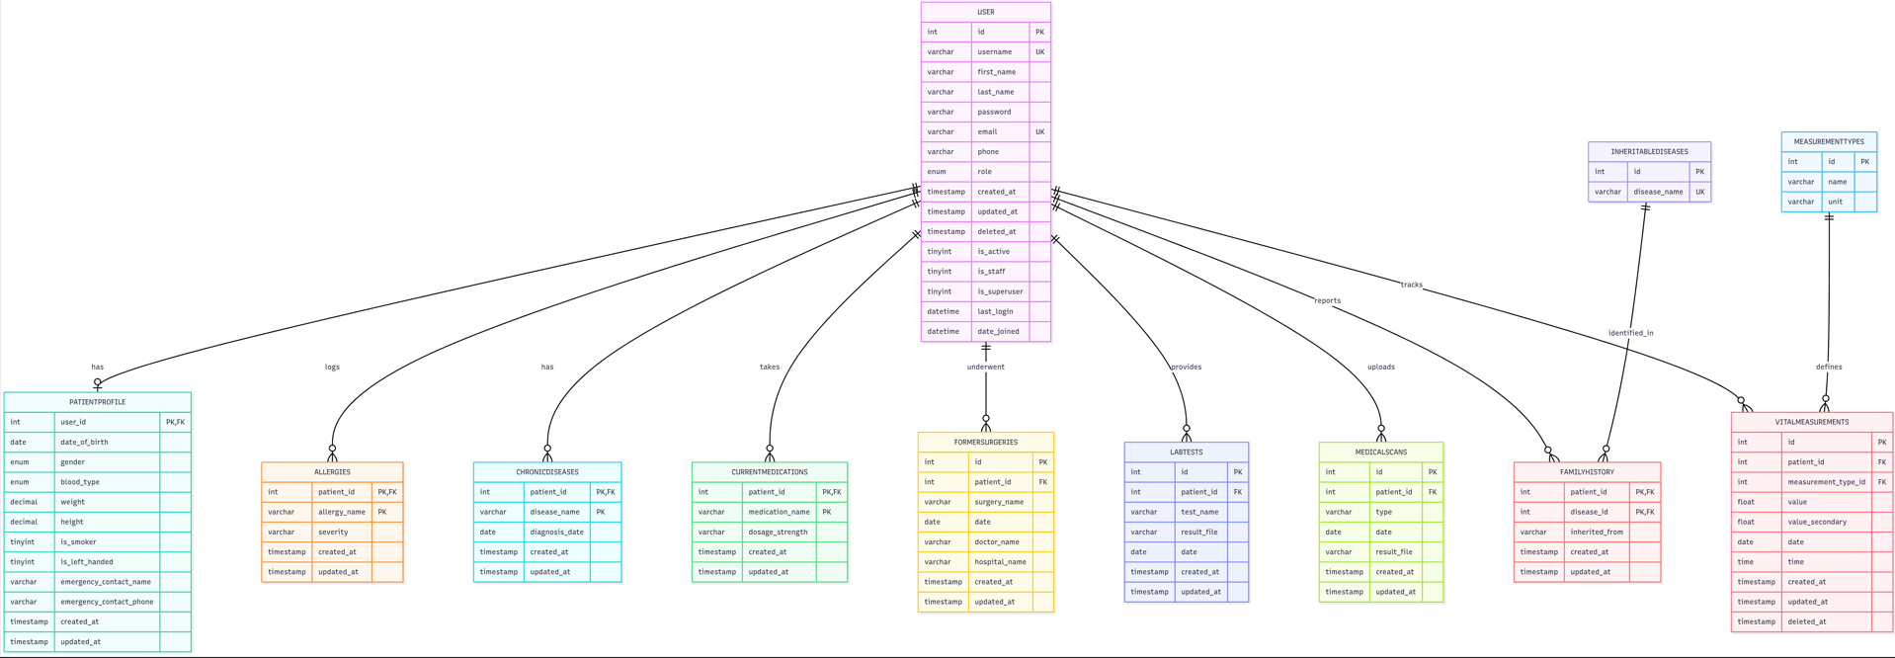
Figure 4.2.1.1 Entity Relationship Diagram (ERD) for Patient Management System This ERD illustrates the centralized database structure of the Patient Management System, showcasing a primary Patient entity connected to various clinical and administrative modules. It highlights the relationships and attributes involved in managing comprehensive patient profiles, including detailed contact information, medical histories, allergies, immunizations, surgeries, social habits, vital signs, medications, and insurance details to ensure integrated healthcare tracking.

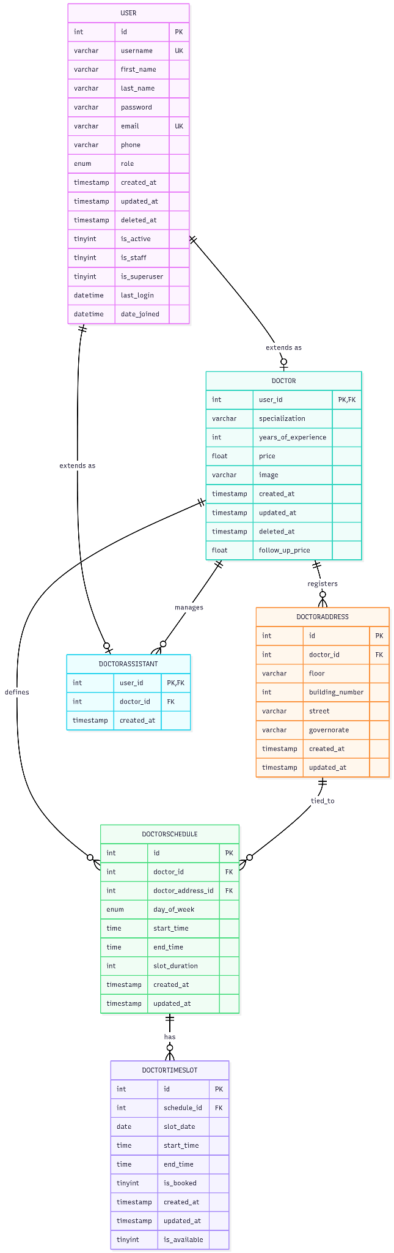
Figure 4.2.1.2: Entity Relationship Diagram (ERD) for Doctor and Schedule Management Subsystem This ERD illustrates the database structure of the Doctor and Scheduling subsystem within the platform, as shown in image_e3b47f.png. It details the core USER entity and how it extends into specialized roles like DOCTOR and DOCTORASSISTANT. Additionally, the diagram defines the management of doctors' professional profiles, including their addresses (DOCTORADDRESS), operational schedules (DOCTORSCHEDULE), and the generation of specific booking time slots (DOCTORTIMESLOT) to streamline the appointment allocation process


Figure 4.2.1.3: Entity Relationship Diagram (ERD) for Doctor Appointment Management Subsystem
This ERD illustrates the database structure of the Doctor Appointment Management subsystem within the platform. It shows how the USER entity represents patients and system users, while the DOCTOR entity stores doctors’ professional information. The diagram also includes DOCTORADDRESS for managing clinic locations and DOCTORTIMESLOT for defining available appointment slots. The central DOCTORAPPOINTMENT entity links patients, doctors, clinic addresses, and time slots to support appointment booking and scheduling. In addition, it manages appointment status, cancellation records, and follow-up appointments through a self-referencing relationship, ensuring efficient coordination of healthcare appointments.

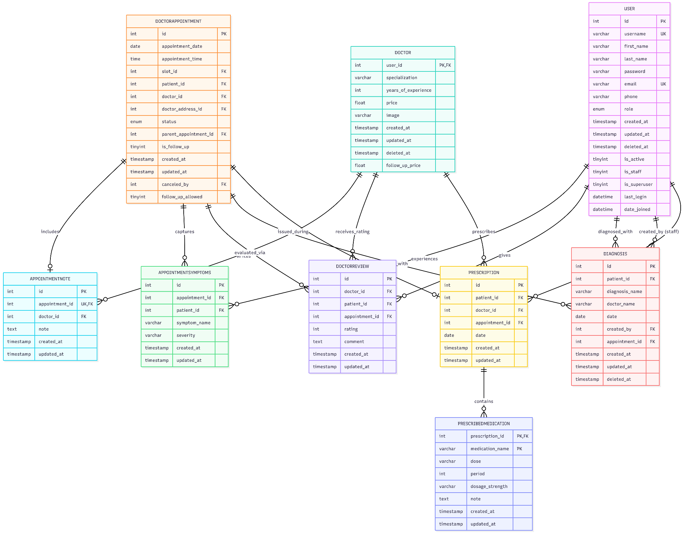
Figure 4.2.1.4: Entity Relationship Diagram (ERD) for Clinical Records and Prescription Management Subsystem
This ERD illustrates the database structure of the Clinical Records and Prescription Management subsystem within the platform. It shows how the DOCTORAPPOINTMENT entity serves as the central component linking patients, doctors, and clinical records generated during medical consultations. The diagram includes APPOINTMENTSYMPTOMS for recording patient symptoms, APPOINTMENTNOTE for documenting consultation notes, and DOCTORREVIEW for capturing patient feedback and ratings related to completed appointments. Additionally, the subsystem manages medical diagnoses through the DIAGNOSIS entity and treatment plans through the PRESCRIPTION entity, which is further associated with PRESCRIBED MEDICATION to store prescribed medications, dosages, and treatment details. Together, these entities provide comprehensive support for patient evaluation, diagnosis, prescription management, and healthcare record maintenance.

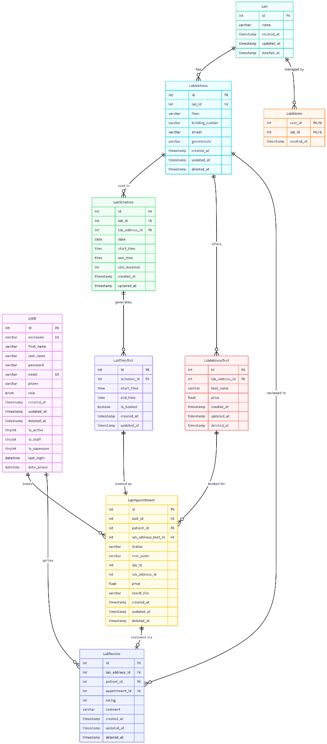
Figure 4.2.1.5: Entity Relationship Diagram (ERD) for Laboratory Appointment and Test Management Subsystem
This ERD illustrates the database structure of the Laboratory Appointment and Test Management subsystem within the platform. It shows how laboratory information is managed through the Lab entity and its associated LabAddress locations, while LabAdmin defines the administrative users responsible for managing laboratories. The diagram also includes LabSchedule and LabTimeSlot, which organize laboratory operating hours and available booking slots for patients. Furthermore, the LabAddressTest entity stores the medical tests offered at each laboratory branch, including pricing information. The central LabAppointment entity coordinates test bookings by linking patients, laboratories, available time slots, and selected tests, while supporting result file management and appointment status tracking. Additionally, the LabReview entity enables patients to provide ratings and feedback on completed laboratory services, ensuring effective management of laboratory appointments, test services, and patient experiences.

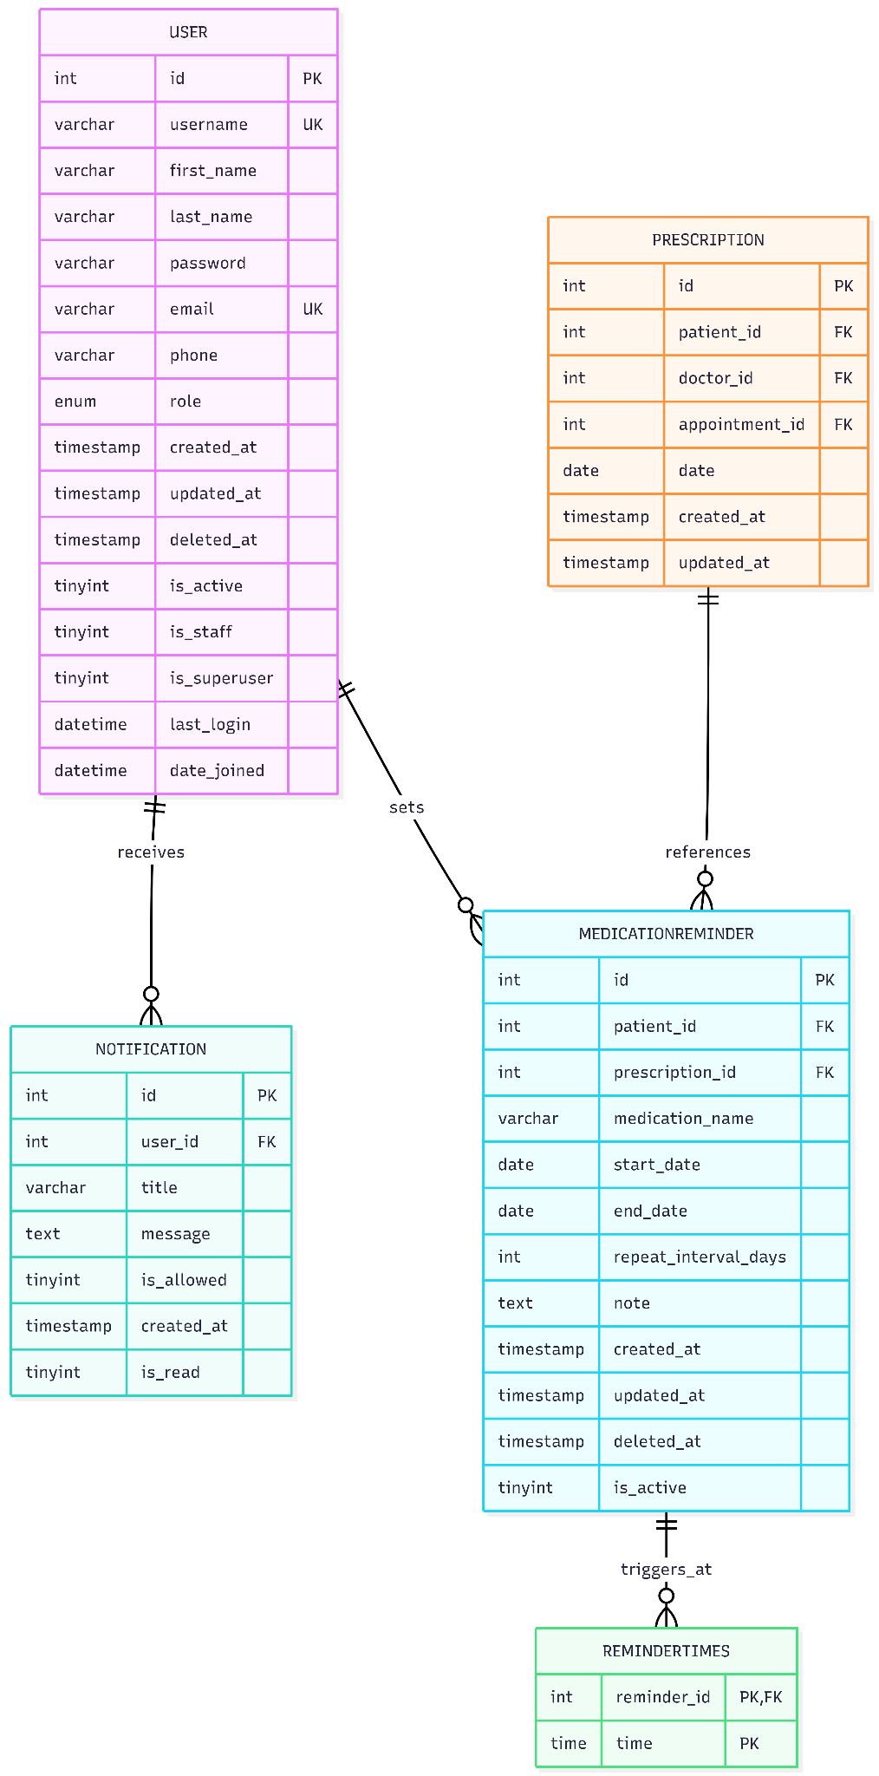

Figure 4.2.1.6: Entity Relationship Diagram (ERD) for Medication Reminder and Notification Management Subsystem
This ERD illustrates the database structure of the Medication Reminder and Notification Management subsystem within the platform. It shows how the MEDICATIONREMINDER entity enables patients to create and manage medication schedules associated with specific prescriptions stored in the PRESCRIPTION entity. Each reminder records medication information, treatment duration, repetition intervals, notes, and activation status. The REMINDERTIMES entity stores one or more scheduled reminder times for each medication reminder, allowing flexible medication scheduling. Additionally, the NOTIFICATION entity manages notifications delivered to users and tracks their content, delivery status, and read status. Together, these entities support medication schedule management, reminder configuration, and user notification services within the healthcare platform.
4.2.2 Database Schema

4.2.2.1 User Table
Table Name | Attribute | Data Type | Key | Description
User | id | INT | PK | Unique user identifier
User | username | VARCHAR | UK | Unique username
User | first_name | VARCHAR |  | User first name
User | last_name | VARCHAR |  | User last name
User | password | VARCHAR |  | Encrypted password
User | email | VARCHAR | UK | User email
User | phone | VARCHAR |  | User phone number
User | role | ENUM |  | User role (patient/doctor/admin)
User | created_at | TIMESTAMP |  | Account creation time
User | updated_at | TIMESTAMP |  | Last update time
User | deleted_at | TIMESTAMP |  | Soft delete timestamp
User | is_active | TINYINT |  | Indicates if account is active
User | is_staff | TINYINT |  | Indicates staff privileges
User | is_superuser | TINYINT |  | Indicates admin privileges
User | last_login | DATETIME |  | Last login timestamp
User | date_joined | DATETIME |  | Registration date

4.2.2.2 Patient profile Table
Table Name | Attribute | Data Type | Key | Description
Patient profile | user_id | INT | PK, FK | References USER table
Patient profile | date_of_birth | DATE |  | Patient birth date
Patient profile | gender | ENUM |  | Patient gender
Patient profile | blood_type | ENUM |  | Blood type
Patient profile | weight | DECIMAL |  | Patient weight
Patient profile | height | DECIMAL |  | Patient height
Patient profile | is_smoker | TINYINT |  | Smoking status
Patient profile | is_left_handed | TINYINT |  | Left-handed indicator
Patient profile | emergency_contact_name | VARCHAR |  | Emergency contact name
Patient profile | emergency_contact_phone | VARCHAR |  | Emergency contact phone
Patient profile | created_at | TIMESTAMP |  | Creation timestamp
Patient profile | updated_at | TIMESTAMP |  | Last update timestamp

4.2.2.3 Doctor Table
Table Name | Attribute | Data Type | Key | Description
Doctor | user_id | INT | PK, FK | References USER table
Doctor | specialization | VARCHAR |  | Doctor specialization
Doctor | years_of_experience | INT |  | Years of experience
Doctor | price | FLOAT |  | Consultation price
Doctor | image | VARCHAR |  | Doctor profile image
Doctor | created_at | TIMESTAMP |  | Creation timestamp
Doctor | updated_at | TIMESTAMP |  | Last update timestamp
Doctor | deleted_at | TIMESTAMP |  | Soft delete timestamp
Doctor | follow_up_price | FLOAT |  | Follow-up appointment price

4.2.2.4 Doctor Appointment Table
Table Name | Attribute | Data Type | Key | Description
Doctor Appointment | id | INT | PK | Appointment identifier
Doctor Appointment | slot_id | INT | FK | References DOCTORTIMESLOT
Doctor Appointment | patient_id | INT | FK | References PATIENTPROFILE
Doctor Appointment | doctor_id | INT | FK | References DOCTOR
Doctor Appointment | doctor_address_id | INT | FK | References DOCTORADDRESS
Doctor Appointment | status | ENUM |  | Appointment status
Doctor Appointment | parent_appointment_id | INT | FK | Parent appointment for follow-up
Doctor Appointment | is_follow_up | TINYINT |  | Indicates follow-up appointment
Doctor Appointment | created_at | TIMESTAMP |  | Creation timestamp
Doctor Appointment | updated_at | TIMESTAMP |  | Last update timestamp
Doctor Appointment | canceled_by | INT | FK | User who canceled appointment
Doctor Appointment | follow_up_allowed | TINYINT |  | Indicates if follow-up is allowed

4.2.2.5 Prescription Table
Table Name | Attribute | Data Type | Key | Description
Prescription | id | INT | PK | Prescription identifier
Prescription | patient_id | INT | FK | References patient
Prescription | doctor_id | INT | FK | References doctor
Prescription | appointment_id | INT | FK | Related appointment
Prescription | date | DATE |  | Prescription date
Prescription | created_at | TIMESTAMP |  | Creation timestamp
Prescription | updated_at | TIMESTAMP |  | Last update timestamp

4.2.2.6 Doctor Review Table
Table Name | Attribute | Data Type | Key | Description
Doctor Review Table | id | INT | PK | Review identifier
Doctor Review Table | doctor_id | INT | FK | Reviewed doctor
Doctor Review Table | patient_id | INT | FK | Patient reviewer
Doctor Review Table | appointment_id | INT | FK | Related appointment
Doctor Review Table | rating | INT |  | Rating value
Doctor Review Table | comment | TEXT |  | Patient feedback
Doctor Review Table | created_at | TIMESTAMP |  | Creation timestamp
Doctor Review Table | updated_at | TIMESTAMP |  | Last update timestamp

4.2.2.7 Allergies Table
Table Name | Attribute | Data Type | Key | Description
Allergies | patient_id | INT | PK, FK | References patient
Allergies | allergy_name | VARCHAR | PK | Allergy name
Allergies | severity | VARCHAR |  | Allergy severity
Allergies | created_at | TIMESTAMP |  | Creation timestamp
Allergies | updated_at | TIMESTAMP |  | Last update timestamp

4.2.2.8 Chronic disease Table
Table Name | Attribute | Data Type | Key | Description
Chronic disease | patient_id | INT | PK, FK | References patient
Chronic disease | disease_name | VARCHAR | PK | Chronic disease name
Chronic disease | diagnosis_date | DATE |  | Diagnosis date
Chronic disease | created_at | TIMESTAMP |  | Creation timestamp
Chronic disease | updated_at | TIMESTAMP |  | Last update timestamp

4.2.2.9 Current Medications Table
Table Name | Attribute | Data Type | Key | Description
Current Medications | patient_id | INT | PK, FK | References patient
Current Medications | medication_name | VARCHAR | PK | Medication name
Current Medications | dosage_strength | VARCHAR |  | Dosage strength
Current Medications | created_at | TIMESTAMP |  | Creation timestamp
Current Medications | updated_at | TIMESTAMP |  | Last update timestamp

4.2.2.10 Family Health History
Table Name | Attribute | Data Type | Key | Description
Family Health History | patient_id | INT | PK, FK | References patient
Family Health History | disease_id | INT | PK, FK | References inheritable disease
Family Health History | inherited_from | VARCHAR |  | Family relation
Family Health History | created_at | TIMESTAMP |  | Creation timestamp
Family Health History | updated_at | TIMESTAMP |  | Last update timestamp

4.2.2.11 Inheritable diseases
Table Name | Attribute | Data Type | Key | Description
Inheritable diseases | id | INT | PK | Disease identifier
Inheritable diseases | disease_name | VARCHAR | UK | Unique disease name

4.2.2.12 Former Surgeries Table
Table Name | Attribute | Data Type | Key | Description
Former Surgeries | id | INT | PK | Surgery identifier
Former Surgeries | patient_id | INT | FK | References patient
Former Surgeries | surgery_name | VARCHAR |  | Surgery name
Former Surgeries | date | DATE |  | Surgery date
Former Surgeries | doctor_name | VARCHAR |  | Surgeon name
Former Surgeries | hospital_name | VARCHAR |  | Hospital name
Former Surgeries | created_at | TIMESTAMP |  | Creation timestamp
Former Surgeries | updated_at | TIMESTAMP |  | Last update timestamp

4.2.2.13 Lab Test Table
Table Name | Attribute | Data Type | Key | Description
Lab Test | id | INT | PK | Test identifier
Lab Test | patient_id | INT | FK | References patient
Lab Test | test_name | VARCHAR |  | Lab test name
Lab Test | result_file | VARCHAR |  | Uploaded result file
Lab Test | date | DATE |  | Test date
Lab Test | created_at | TIMESTAMP |  | Creation timestamp
Lab Test | updated_at | TIMESTAMP |  | Last update timestamp

4.2.2.14 Medical scans Table
Table Name | Attribute | Data Type | Key | Description
Medical scans | id | INT | PK | Scan identifier
Medical scans | patient_id | INT | FK | References patient
Medical scans | type | VARCHAR |  | Scan type
Medical scans | date | DATE |  | Scan date
Medical scans | result_file | VARCHAR |  | Uploaded scan file
Medical scans | created_at | TIMESTAMP |  | Creation timestamp
Medical scans | updated_at | TIMESTAMP |  | Last update timestamp

4.2.2.15 Measurement types Table
Table Name | Attribute | Data Type | Key | Description
Measurement types | id | INT | PK | Measurement type identifier
Measurement types | name | VARCHAR |  | Measurement name
Measurement types | unit | VARCHAR |  | Measurement unit

4.2.2.16 Vital measurements Table
Table Name | Attribute | Data Type | Key | Description
Vital measurements | id | INT | PK | Measurement identifier
Vital measurements | patient_id | INT | FK | References patient
Vital measurements | measurement_type_id | INT | FK | References measurement type
Vital measurements | value | FLOAT |  | Primary measurement value
Vital measurements | value_secondary | FLOAT |  | Secondary measurement value
Vital measurements | date | DATE |  | Measurement date
Vital measurements | time | TIME |  | Measurement time
Vital measurements | created_at | TIMESTAMP |  | Creation timestamp
Vital measurements | updated_at | TIMESTAMP |  | Last update timestamp
Vital measurements | deleted_at | TIMESTAMP |  | Soft delete timestamp

4.2.2.17 Notification Table
Table Name | Attribute | Data Type | Key | Description
Notification | id | INT | PK | Notification identifier
Notification | user_id | INT | FK | References user
Notification | title | VARCHAR |  | Notification title
Notification | message | TEXT |  | Notification content
Notification | is_allowed | TINYINT |  | Notification permission
Notification | created_at | TIMESTAMP |  | Creation timestamp
Notification | is_read | TINYINT |  | Read status

4.2.2.18 Doctor address Table
Table Name | Attribute | Data Type | Key | Description
Doctor address | id | INT | PK | Address identifier
Doctor address | doctor_id | INT | FK | References doctor
Doctor address | floor | VARCHAR |  | Clinic floor
Doctor address | building_number | INT |  | Building number
Doctor address | street | VARCHAR |  | Street name
Doctor address | governorate | VARCHAR |  | Governorate
Doctor address | created_at | TIMESTAMP |  | Creation timestamp
Doctor address | updated_at | TIMESTAMP |  | Last update timestamp

4.2.2.19 Doctor assistant Table
Table Name | Attribute | Data Type | Key | Description
Doctor assistant | user_id | INT | PK, FK | Assistant user reference
Doctor assistant | doctor_id | INT | FK | Assigned doctor
Doctor assistant | created_at | TIMESTAMP |  | Creation timestamp

4.2.2.20 Doctor schedule Table
Table Name | Attribute | Data Type | Key | Description
Doctor schedule | id | INT | PK | Schedule identifier
Doctor schedule | doctor_id | INT | FK | References doctor
Doctor schedule | doctor_address_id | INT | FK | References clinic address
Doctor schedule | day_of_week | ENUM |  | Working day
Doctor schedule | start_time | TIME |  | Start time
Doctor schedule | end_time | TIME |  | End time
Doctor schedule | slot_duration | INT |  | Slot duration in minutes
Doctor schedule | created_at | TIMESTAMP |  | Creation timestamp
Doctor schedule | updated_at | TIMESTAMP |  | Last update timestamp

4.2.2.21 Doctor timeslot Table
Table Name | Attribute | Data Type | Key | Description
Doctor timeslot | id | INT | PK | Slot identifier
Doctor timeslot | schedule_id | INT | FK | References doctor schedule
Doctor timeslot | slot_date | DATE |  | Slot date
Doctor timeslot | start_time | TIME |  | Slot start time
Doctor timeslot | end_time | TIME |  | Slot end time
Doctor timeslot | is_booked | TINYINT |  | Booking status
Doctor timeslot | created_at | TIMESTAMP |  | Creation timestamp
Doctor timeslot | updated_at | TIMESTAMP |  | Last update timestamp
Doctor timeslot | is_available | TINYINT |  | Availability status

4.2.2.22 Appointment note Table
Table Name | Attribute | Data Type | Key | Description
Appointment note | id | INT | PK | Note identifier
Appointment note | appointment_id | INT | UK, FK | References appointment
Appointment note | doctor_id | INT | FK | References doctor
Appointment note | note | TEXT |  | Medical note
Appointment note | created_at | TIMESTAMP |  | Creation timestamp
Appointment note | updated_at | TIMESTAMP |  | Last update timestamp

4.2.2.23 Appointment symptoms Table
Table Name | Attribute | Data Type | Key | Description
Appointment symptoms | id | INT | PK | Symptom identifier
Appointment symptoms | appointment_id | INT | FK | References appointment
Appointment symptoms | patient_id | INT | FK | References patient
Appointment symptoms | symptom_name | VARCHAR |  | Symptom name
Appointment symptoms | severity | VARCHAR |  | Symptom severity
Appointment symptoms | created_at | TIMESTAMP |  | Creation timestamp
Appointment symptoms | updated_at | TIMESTAMP |  | Last update timestamp

4.2.2.24 Diagnoses Table
Table Name | Attribute | Data Type | Key | Description
Diagnoses | id | INT | PK | Diagnosis identifier
Diagnoses | patient_id | INT | FK | References patient
Diagnoses | diagnosis_name | VARCHAR |  | Diagnosis name
Diagnoses | doctor_name | VARCHAR |  | Doctor name
Diagnoses | date | DATE |  | Diagnosis date
Diagnoses | created_by | INT | FK | Staff creator
Diagnoses | appointment_id | INT | FK | Related appointment
Diagnoses | created_at | TIMESTAMP |  | Creation timestamp
Diagnoses | updated_at | TIMESTAMP |  | Last update timestamp
Diagnoses | deleted_at | TIMESTAMP |  | Soft delete timestamp

4.2.2.25 Prescribed medication Table
Table Name | Attribute | Data Type | Key | Description
Prescribed medication | prescription_id | INT | PK, FK | References prescription
Prescribed medication | medication_name | VARCHAR | PK | Medication name
Prescribed medication | dose | VARCHAR |  | Medication dose
Prescribed medication | period | INT |  | Treatment period
Prescribed medication | dosage_strength | VARCHAR |  | Dosage strength
Prescribed medication | note | TEXT |  | Additional notes
Prescribed medication | created_at | TIMESTAMP |  | Creation timestamp
Prescribed medication | updated_at | TIMESTAMP |  | Last update timestamp

4.2.2.26 Medication reminder Table
Table Name | Attribute | Data Type | Key | Description
Medication reminder | id | INT | PK | Reminder identifier
Medication reminder | patient_id | INT | FK | References patient
Medication reminder | prescription_id | INT | FK | References prescription
Medication reminder | medication_name | VARCHAR |  | Medication name
Medication reminder | start_date | DATE |  | Reminder start date
Medication reminder | end_date | DATE |  | Reminder end date
Medication reminder | repeat_interval_days | INT |  | Reminder interval
Medication reminder | note | TEXT |  | Reminder notes
Medication reminder | created_at | TIMESTAMP |  | Creation timestamp
Medication reminder | updated_at | TIMESTAMP |  | Last update timestamp
Medication reminder | deleted_at | TIMESTAMP |  | Soft delete timestamp
Medication reminder | is_active | TINYINT |  | Reminder active status

4.2.2.27 Reminder Time Table
Table Name | Attribute | Data Type | Key | Description
Reminder Time | reminder_id | INT | PK, FK | References reminder
Reminder Time | time | TIME | PK | Reminder time

4.3 User Interface Design
4.4 Class Diagram
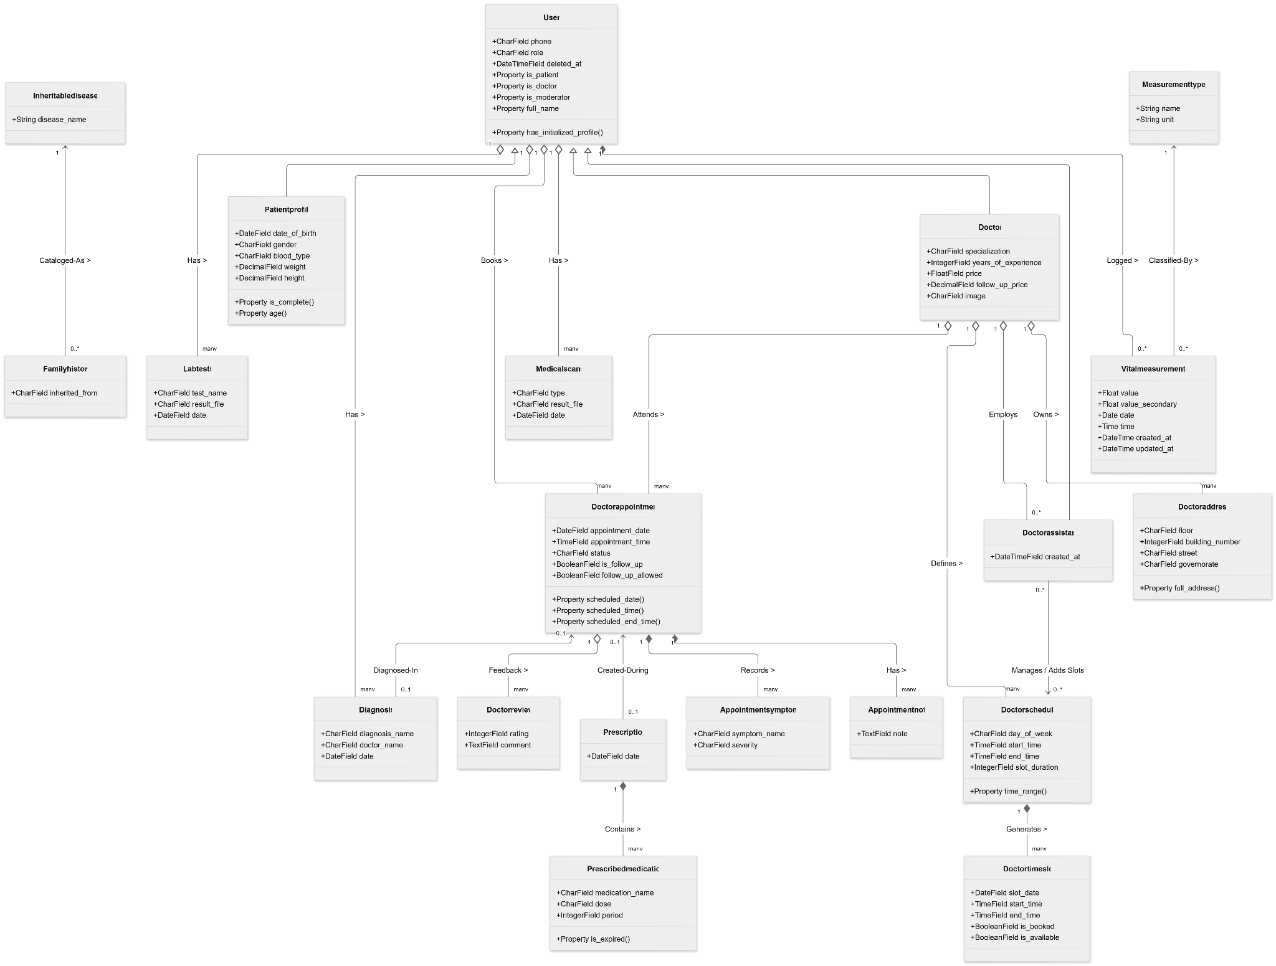
The UML Class Diagram represents the static structural view of the DocBot platform. It details the system's micro-architecture by showcasing the essential classes, their internal attributes, core operational methods, and the structural configurations that govern the backend. This diagram maps out how individual models within the Django framework interact with the SQL database, demonstrating object-oriented principles such as inheritance, association, aggregation, and composition among the system’s primary clinical and user entities.
Figure 4.4: UML Class Diagram of DocBot platform showing core entities and database relationships.
4.5 Sequence Diagrams

4.5.1 Log in sequence diagram
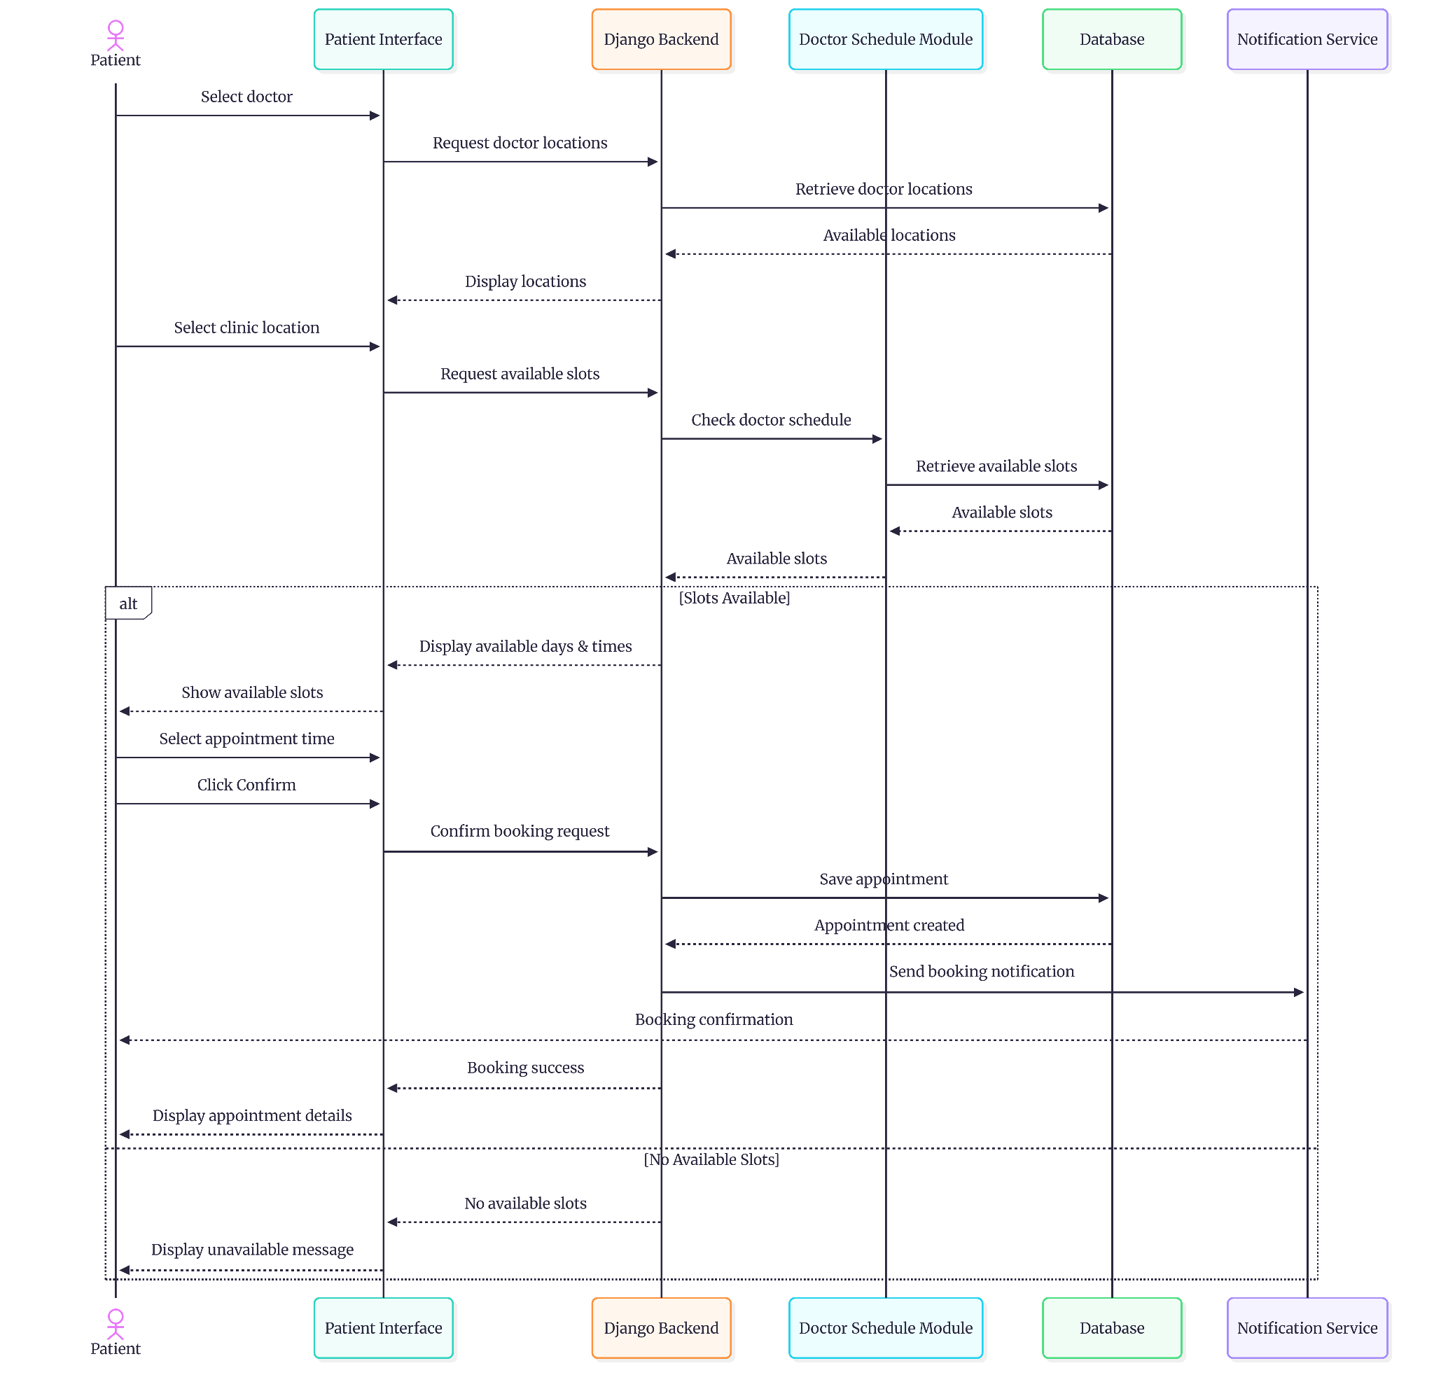

4.5.2 Booking Sequence Diagram
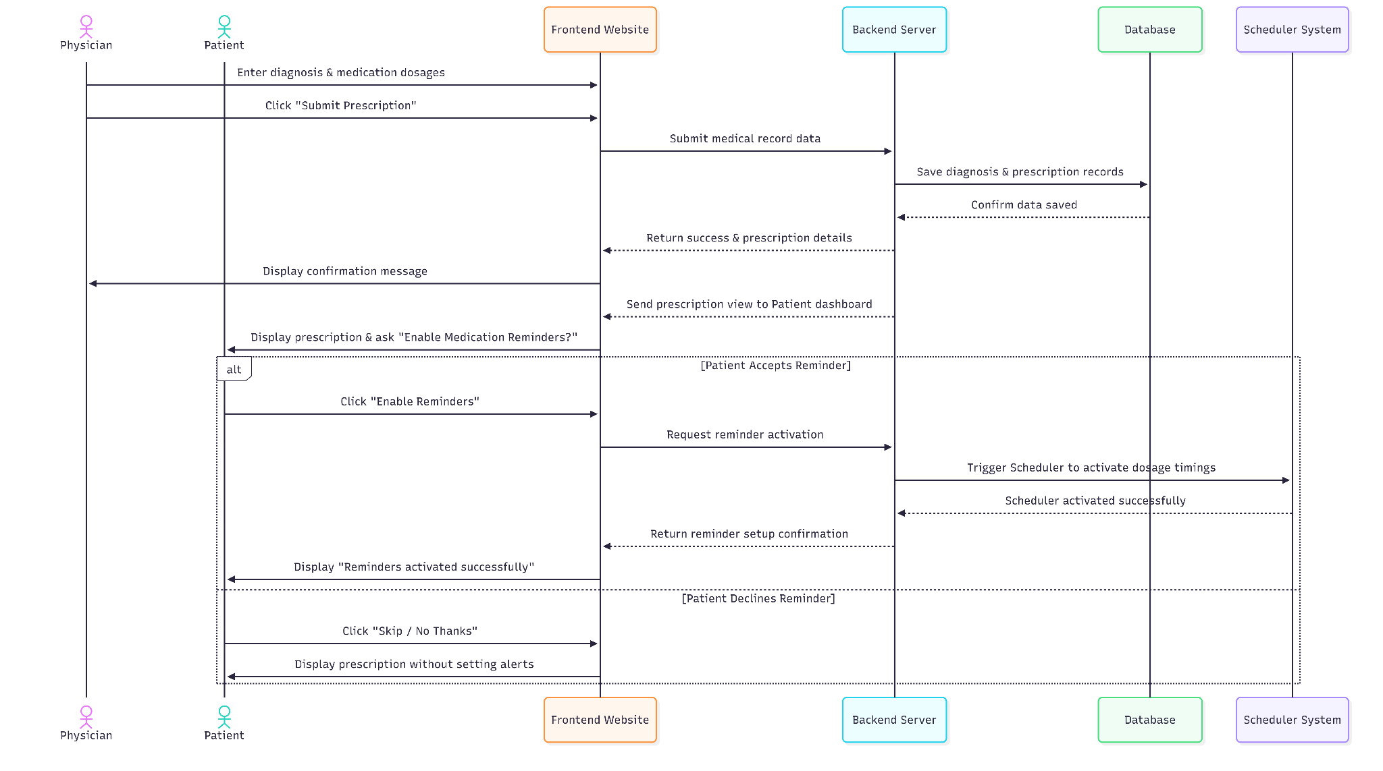
4.5.3 Diagnose submission and prescription sequence diagram

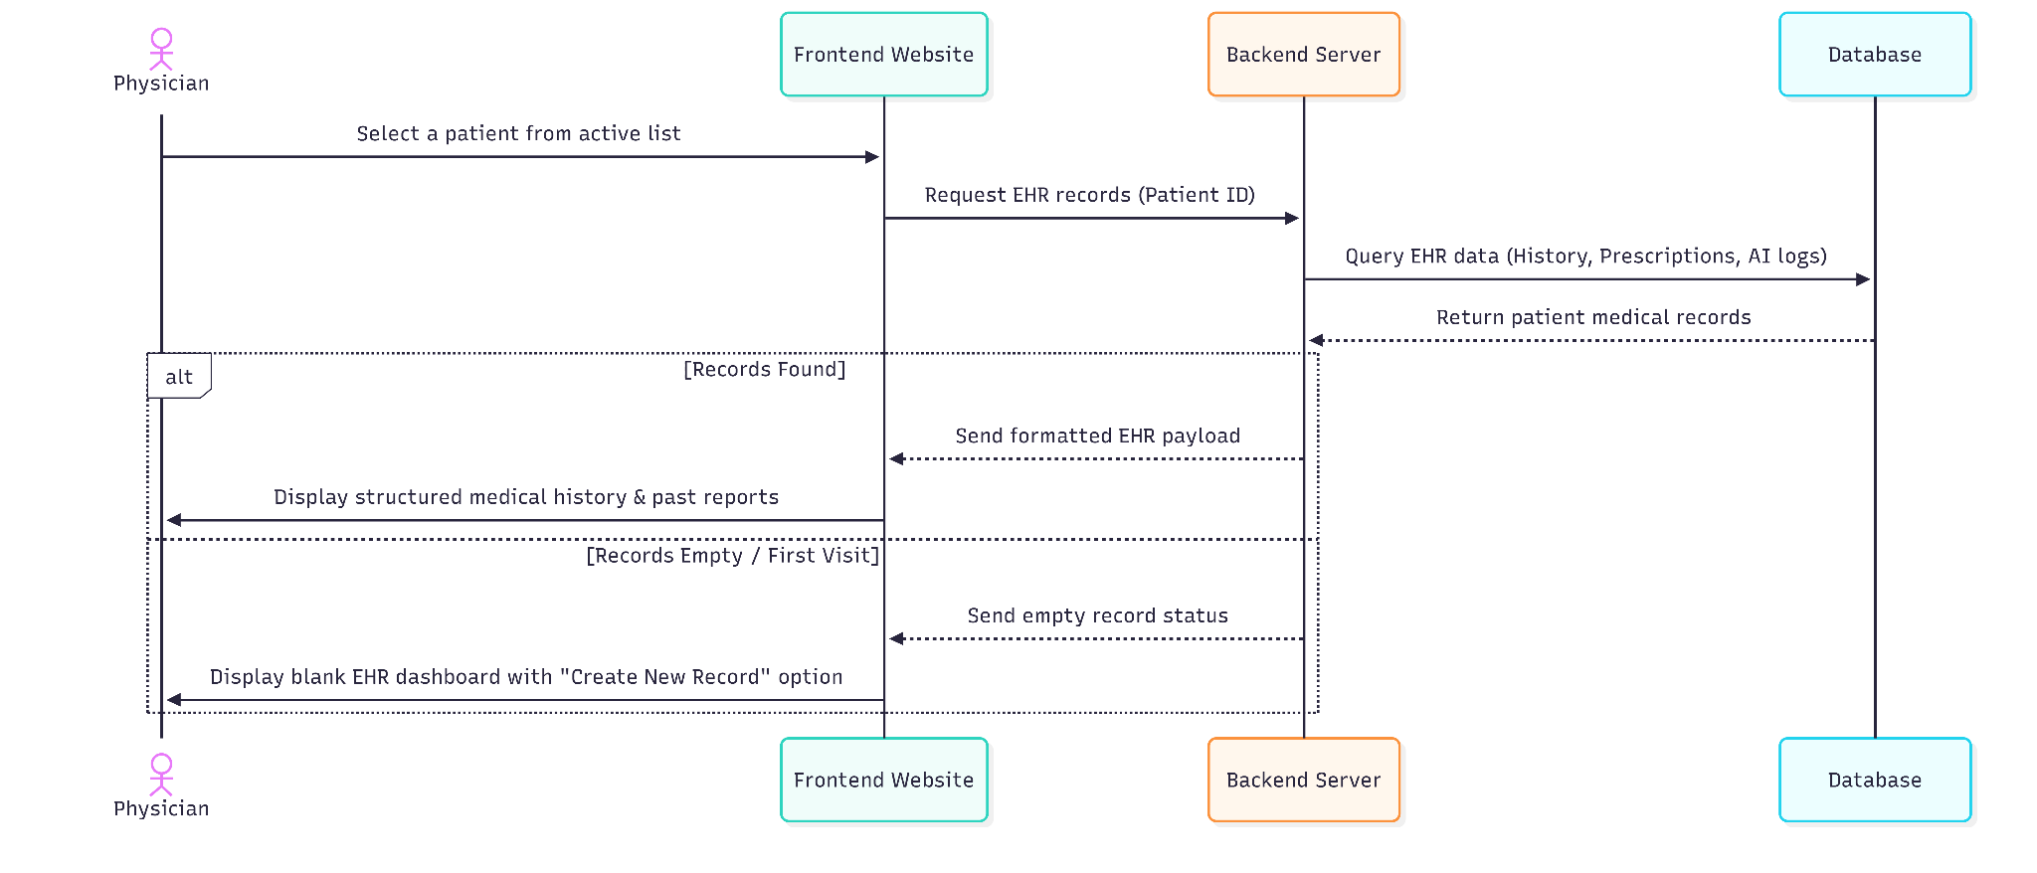

4.5.5 EHR Retrieving Sequence Diagram

4.6 Activity Diagrams/ Flowcharts
4.6.1 Login Flowchart

4.6.2 Appointment Booking Flowchart

4.6.3 Doctor’s Appointment Flowchart

4.7 Technology Stack

Layer | Technology / Tool | Justification
Frontend | HTML5 ,CSS3, JavaScript ,Django Templates | Provides dynamic server-side rendering, seamless integration with Django backend, lightweight architecture, and efficient page rendering for chatbot, booking, and appointment interfaces
Backend | Python, Django 6, N8N, Cloudinary | High-level web framework with built-in security, rapid development support, structured MVC architecture, and excellent support for healthcare workflow management. It is integrated with N8N for AI chatbot workflow automation and Cloudinary for secure cloud-based medical media storage
Database | MySQL 8 | Ensures ACID compliance, relational integrity, secure structured storage for patients, doctors, appointments, prescriptions, and EHR records
Authentication | Django Built-in Authentication, Password Hashing | Provides secure user authentication, session management, role-based access control, and built-in protection against common security vulnerabilities
Version Control | Git ,GitHub | Enables collaborative development, version tracking, rollback support, and efficient project management
IDE | Visual Studio Code | Lightweight, supports Python/Django extensions, integrated debugging, Git support, and efficient full-stack development environment
Deployment

Testing | Manual Integration Testing, Browser DevTools, N8N Execution Logs | Verifies user interface workflows manually via the browser, while utilizing N8N's built-in execution logs to test and monitor webhook data flows between the AI and the backend.

CHAPTER 5
- Implementation

5.1 Development Methodology
5.2 Development Environment Setup
The development, database integration, and configuration setup for the project were successfully established using the following specialized technical specifications, framework dependencies, and engineering tools:
Technical Component | Specifications & Tools Used
Operating System | Windows 11 Home / Pro, Kubuntu 26.04 LTS
IDE / Editor | Visual Studio Code (VS Code)
Runtime / SDK | Python v3.13.0
Web Framework | Django v6.0.4
Package Manager | pip (Python Package Installer)
Database Server | MySQL 8.0 Community Server
Version Control | Git v2.53.0 + GitHub (Private Architecture Repository)
Project Management | GitHub Projects / Trello / WhatsApp Group Coordination

5.3 Project Structure
The architectural structure of the DocBot system is engineered using Django’s modular blueprint. To achieve a high degree of maintainability, isolation of business concerns, and structured scalability, the system configuration is decoupled from the specific functional components. The directory tree below delineates the technical organization of the root environment, the core system settings, and the 6 specialized sub-applications:

DocBot_Project/
├── core/ # Core System Configuration & Middleware
│ ├── __init__.py
│ ├── settings.py # Global Project Settings & Database Routing
│ ├── urls.py # Master URL Router
│ └── wsgi.py # Web Server Gateway Interface Entry
│
├── patient/ # Patient Sub-system & Electronic Health Records
│ ├── migrations/ # Database Schema Migrations Log
│ ├── models.py # Patient Schema & Profile Data Structures
│ └── views.py # Patient-Facing Dashboard Business Logic
│
├── doctor/ # Physician Portals & Dynamic Schedules
│ ├── migrations/
│ ├── models.py # Doctor Schema & Shift Slot Structures
│ └── views.py # Doctor Consultation Panel Logic
│
├── systemadmin/ # System Administration, Metrics & Logs
│ ├── migrations/
│ ├── models.py # Audit Trails & Role Access Matrix
│ └── views.py # RBAC Control Panels & Analytic Views
│
├── appointment/ # Booking Engine & Core Scheduling Logic
│ ├── migrations/
│ ├── models.py # Reservation & Session Database Schemas
│ └── views.py # Slot Validation & Reservation Logic
│
├── notification/ # Asynchronous Alerts & Communication Layer
│ ├── migrations/
│ ├── models.py # Dispatch Queue & Template Schemas
│ └── views.py # Real-time Webhook & Dispatch Controller
│
├── chatbot/ # AI Chatbot Assistant Core Module
│ ├── migrations/
│ ├── models.py # NLP Intent Logs & Conversation History
│ └── views.py # Predictive Inference & Symptom Processing
│
├── manage.py # Django Administrative CLI Execution Engine
└── requirements.txt # System Dependencies & Explicit Production Libraries

5.4 Implementation of Key Modules
5.4.1 Module 1: User Authentication Module
Implementation Approach:
The User Authentication module provides a secure gateway to manage user identity and control dashboard access based on specific account roles. The system utilizes Django’s built-in authentication system backed by a MySQL database. To maintain clean structural data, a unified core User model handles authentication credentials (username, password, email), which extends via one-to-one database relationships into separate profiles including (Patientprofile,Doctor,SystemAdmin,Moderator,DoctorAssistant). Upon successful login, a dynamic routing mechanism checks the user's role type and securely redirects them to their respective dashboard, preventing unauthorized structural cross-access.
Authentication Workflow:
1. Request Initiation: The process begins at the login/registration interface where user credentials are submitted via HTTP POST.
2. Structural Validation: The system executes immediate checks for email formatting (Regex) and verifies that the account has not been deactivated (checking the deleted_at timestamp).
3. Cryptographic Verification: Incoming passwords undergo PBKDF2 hashing to be securely compared against the stored hash in the MySQL database.
4. Session & Token Generation: Upon successful matching, Django’s session engine generates a unique session token for the user.
5. Role Mapping & Redirection: The get_role_redirect_url utility intercepts the user object, identifies their role (Patient, Doctor, Doctor_Assistant, Moderator, System_Admin), and executes a dynamic HTTP redirect to the corresponding secure dashboard.
Main Functions:
· get_role_redirect_url(user): A core utility function that evaluates the user's role field (e.g., Patient, Doctor, Doctor_Assistant, Moderator, System_Admin) and returns the corresponding dashboard URL mapping.
· login_view(request): Handles HTTP POST and GET requests for authentication. It captures user inputs, performs backend verification via Django's authenticate method, verifies account deactivation status using deleted_at, and initiates the session.
· register_view(request): Manages new user registration pipelines. It enforces structural input validation (username, email regex, password strength), instantiates a core User instance with a designated 'Patient' role, and subsequently generates an empty Patientprofile record.
· logout_view(request): Flushes session tokens, safely logs out the user via Django's core logout engine, and securely redirects back to the system's entry page.
Design Patterns Used:
· Factory Pattern (Onboarding Instance Creation): The registration pipeline uses a factory logic during patient account setup. When a user submits valid credentials, the system instantiates the core User entity first, then automatically generates the matching profile record (Patientprofile) linked to that specific account identity.
· Role-Based Access Control (RBAC) Pattern: Instead of using a generic home route, the system leverages an explicit authorization registry mapping roles to dedicated dashboards (Patient, Doctor, Doctor_Assistant, Moderator, System_Admin) ensuring that users are restricted to their boundaries upon login.
Security Measures:
· Cryptographic Password Hashing: To ensure data protection and prevent credential exposure, the system never stores raw user passwords within the MySQL database. During registration via create_user, the module automatically enforces cryptographic password hashing utilizing Django's PBKDF2 algorithm combined with a SHA-256 hash. This architecture guarantees that even in the case of unauthorized database access, user secrets remain completely encrypted and unreadable.
Key Code Snippet:

def get_role_redirect_url(user):
"””Return the dashboard URL based on user role."””
role_urls = {
'Patient': '/patient/dashboard/',
'Doctor': '/doctor/dashboard/',
'Doctor_Assistant': '/doctor/assistant-dashboard/', 'Moderator': '/admin-panel/dashboard/',
'System_Admin': '/admin-panel/dashboard/',
}
return role_urls.get(user.role, '/')

def login_view(request):
"""Login view using username + password with role deactivation check."""
if request.user.is_authenticated:
return redirect(get_role_redirect_url(request.user))

if request.method == 'POST':
username = request.POST.get('username', '').strip()
password = request.POST.get('password', '')
user = authenticate(request, username=username, password=password)
if user is not None:
if user.deleted_at is not None:
return render(request, 'core/login.html', {'error': 'This account has been deactivated.'})
login(request, user)
return redirect(get_role_redirect_url(user))

5.4.2 Module 2: Core Business Logic Module

• Chatbot Pre-requisite Constraint:The system requires the patient to complete their Electronic Health Record (EHR) via the chatbot interaction as a necessary step to unlock the appointment booking feature.

• Automated EHR Population: Through the patient's conversation with the chatbot, the Electronic Health Record (EHR) is automatically filled based on the user's inputs.

• Symptom Triage Assessment: The chatbot asks the patient a set of questions to analyze and determine whether the patient's condition is critical (dangerous) or if the symptoms are mild and simple.

• Smart Doctor Recommendation: After assessing the severity, the chatbot recommends a doctor with the appropriate specialization suitable for the patient's condition.

• Appointment Booking & Double-Booking Prevention: The system manages the booking of an appointment with the selected doctor while strictly preventing repeated or overlapping bookings; one specific time slot can only be reserved for one single patient.

• Medication Reminder Notifications: The system automatically dispatches notifications to remind patients of their specified medication schedules.
5.4.3 Module 3: Database Access Layer
The Database Access Layer is responsible for managing all interactions between the application and the MySQL database. The system utilizes Django's Object Relational Mapper (ORM) to perform database operations without requiring direct SQL statements. This approach improves maintainability, security, and code readability while providing a structured interface for accessing and manipulating data.
The database layer interacts with several core entities, including Doctor, Doctor_Assistant, Moderator, Super_Admin, DoctorSchedule, DoctorTimeSlot, Diagnosis, Allergies, ChronicDiseases, CurrentMedications, FamilyHistory, FormerSurgeries,Notification, MedicationReminder, MedicalScans, and Appointment-related records.
Database operations are implemented using Django ORM's CRUD functionalities. New records are created using the objects.create() method. For example, the system creates doctor schedules, appointment notes, medical scans, chronic disease records, medication records, and available appointment time slots through ORM-based create operations.
Data retrieval is performed using query methods such as filter(), get(), and exists(). For example, patient diagnoses are retrieved using filtered queries based on the currently authenticated user, while medical history records are checked through existence queries before enabling certain chatbot functionalities.
Updates to existing records are handled using the save() method. Examples include updating doctor consultation fees, modifying schedule information, and maintaining record timestamps. Record deletion is implemented using the delete() method, which is used when removing schedules and unbooked appointment time slots.
The Database Access Layer extensively utilizes Django ORM query methods to perform data manipulation and retrieval operations.
Filtering Records
The filter() method is used to retrieve records that satisfy specific conditions. Examples include retrieving patient diagnoses and checking medical history information:

diagnoses = Diagnosis.objects.filter(patient=user).order_by('-date')
chatbot_data_exists = (
Allergies.objects.filter(patient=user).exists() or
Chronicdiseases.objects.filter(patient=user).exists() or
Currentmedications.objects.filter(patient=user).exists()
)
Existing records are modified by updating object attributes and persisting changes through the save() method:

doctor.price = price
doctor.follow_up_price = follow_up_price
doctor.updated_at = timezone.now()
doctor.save()
Creating Records
New database entries are created using the objects.create() method. This approach is used for schedules, appointment notes, medical scans, diseases, medications, and appointment time slots:

Doctorschedule.objects.create()
Doctortimeslot.objects.create()
Appointmentnote.objects.create()
Updating Records
Existing records are modified by updating object attributes and persisting changes through the save() method:

doctor.price = price
doctor.follow_up_price = follow_up_price
doctor.updated_at = timezone.now()
doctor.save()
Another example updates schedule information:
schedule.day_of_week = request.POST.get('day_of_week')
schedule.updated_at = timezone.now()
schedule.save()
Deleting Records
The delete() method is used to remove records that are no longer required. For example, when deleting a schedule, all future unbooked time slots associated with that schedule are removed first:

Doctortimeslot.objects.filter(
schedule=schedule,
slot_date__gte=date.today(),
is_booked=0
).delete()
schedule.delete()
Existence Checks
The exists() method is used to verify whether matching records are available without retrieving complete datasets, improving query efficiency:

Allergies.objects.filter(patient=user).exists()
This operation is used when determining whether sufficient patient medical history data exists before enabling chatbot-assisted healthcare services.
Database connections are managed automatically through Django's built-in connection management mechanism. No additional connection pooling configuration is currently implemented. Django establishes and maintains database connections as needed during request processing.
Transaction handling currently relies on Django's default transaction management behavior. The implementation does not use custom transaction blocks such as transaction.atomic(), and database operations are executed through standard ORM methods.
To enhance security, all database interactions are performed through Django ORM rather than dynamically generated SQL statements. This approach provides protection against SQL Injection attacks by utilizing parameterized database queries and framework-level input handling.
5.4.4 Module 4: [ User Interface Module]
5.4.5 Module 5: Reporting Notification Module
To implement solid system scalability and separation of concerns, the DocBot architectural scope is isolated into 6 separate application environments. Each submodule completely wraps its own discrete database tables, functional routing, and clinical data logic as outlined systematically below:
Sub-system / Module | Architectural Scope & Functionality
Patient Module | Manages secure patient portal access, medical history registration, profile editing, data privacy constraints, and the custom patient-facing dashboard reporting view.
Doctor Module | Coordinates credential verification, automated work shifts, scheduling adjustments, active consulting states, and the specialized clinical panel for reviewing records.
Systemadmin Module | Provides high-level system logs overview, system configurations, system summaries , and strict role-based access control (RBAC) to securely manage user permissions.
Appointment Module | Executes the central scheduling engine which validates real-time physician availability, manages advanced bookings, cancellations, and operational clinical sessions.
Notification Module | Handles transactional alert pipelines, managing scheduled automated text/email dispatches to reliably synchronize operations between doctors and patients.
Chatbot Module | Houses the NLP conversational pipelines, processing incoming medical symptoms to run safe, initial health evaluations and assist patients with preliminary health queries.

5.5 Key Code Snippets
This section presents selected code snippets that implement critical business rules and core backend functionalities within the DocBot system. The included examples demonstrate key validation mechanisms, scheduling controls, security checks, chatbot integration logic, and appointment management processes. Each snippet highlights how the system ensures data integrity, prevents operational conflicts, and supports reliable healthcare service delivery.
5.5.1 Doctor Schedule Validation and Conflict Detection
Programming Language:Python (Django)

@doctor_required
def schedule_add(request):
doctor = Doctor.objects.get(user=request.user)
if request.method == 'POST':
start_time_str = request.POST.get('start_time')
end_time_str = request.POST.get('end_time')

if start_time_str < "10:00":
messages.error(request, 'Error: Appointments must start from 10:00 AM onwards.')
return redirect('doctor_schedule_add')

if start_time_str >= end_time_str:
messages.error(request, 'Error: End time must be after start time.')
return redirect('doctor_schedule_add')

if _is_schedule_overlapping(doctor, request.POST.get('day_of_week'), start_time_str, end_time_str):
messages.error(request, 'Error: This schedule overlaps with an existing one on the same day.')
return redirect('doctor_schedule_add')

This function handles doctor schedule creation while validating appointment rules. It ensures that schedules start within allowed working hours, verifies that the end time is after the start time, and prevents overlapping schedules on the same day. This logic improves scheduling accuracy and avoids booking conflicts in the healthcare system.
5.5.2 Appointment Session Date Validation

Programming Language:Python (Django)

@doctor_required
def appointment_start(request, pk):
doctor = Doctor.objects.get(user=request.user)
appointment = get_object_or_404(Doctorappointment, pk=pk, doctor=doctor, status='Booked')
if request.method == 'POST':
scheduled_date = appointment.scheduled_date
if scheduled_date != date.today():
messages.error(request, 'You can only start an appointment on its scheduled day.')
return redirect('doctor_appointment_detail', pk=pk)

This function ensures that doctors can only start appointment sessions on the officially scheduled date. The validation prevents unauthorized or premature access to patient consultation sessions and maintains workflow integrity within the healthcare system.

5.5.3 Appointment Completion Validation
Programming Language:Python (Django)

def appointment_complete(request, pk):
doctor = Doctor.objects.get(user=request.user)
appointment = get_object_or_404(Doctorappointment, pk=pk, doctor=doctor, status='In progress')
if request.method == 'POST':
# Ensure all prescriptions have at least one medication
empty_prescriptions = Prescription.objects.filter(appointment=appointment).annotate(med_count=Count('prescribedmedication')).filter(med_count=0)
if empty_prescriptions.exists():
messages.error(request, 'Error: You have created a prescription but haven\'t added any medications to it. Please add medications or delete the empty prescription.')
return redirect('doctor_appointment_detail', pk=pk)

# Enforce conditional validation
currently_has_d = Diagnosis.objects.filter(appointment=appointment).exists()
currently_has_p = Prescription.objects.filter(appointment=appointment).exists()
currently_has_n = Appointmentnote.objects.filter(appointment=appointment).exists()

if not currently_has_d and not currently_has_p and not currently_has_n:
messages.error(request, "Error: At least one of Diagnoses, Doctor Notes, or Prescription fields must be populated to complete the session.")
return redirect('doctor_appointment_detail', pk=pk)

appointment.status = 'Completed'
appointment.updated_at = timezone.now()
appointment.save()

This function validates medical session completion before changing the appointment status to "Completed." It ensures that all prescriptions contain medications and verifies that both diagnoses and prescriptions are documented. These validations help maintain data integrity, improve patient safety, and prevent incomplete medical records.

5.5.4 AI-Chatbot Assisted Appointment Booking Workflow
Programming Language: Python (Django)

def book_appointment(request, doctor_id):
if not request.user.has_initialized_profile:
messages.warning(request, "To help your doctor prepare for your visit, please complete your health profile with our AI assistant first. Let's finish your quick chat, and then you can book your appointment right away!")
return redirect('chatbot_chat')

doctor = get_object_or_404(Doctor.objects.select_related('user'), user_id=doctor_id)
addresses = Doctoraddress.objects.filter(doctor=doctor)

selected_address = request.GET.get('address')
available_slots = None

if selected_address:
now_local = timezone.localtime(timezone.now())
current_date = now_local.date()
current_time = now_local.time()
available_slots = Doctortimeslot.objects.filter(
schedule__doctor=doctor,
schedule__doctor_address_id=selected_address,
is_booked=0,
is_available=1,
).filter(
Q(slot_date__gt=current_date) |
Q(slot_date=current_date, start_time__gt=current_time)
).select_related('schedule__doctor_address').order_by('slot_date', 'start_time')

if request.method == 'POST':
slot_id = request.POST.get('slot_id')
address_id = request.POST.get('address_id')
slot = get_object_or_404(Doctortimeslot, pk=slot_id, is_booked=0, is_available=1)

appointment = Doctorappointment.objects.create(
slot=slot,
appointment_date=slot.slot_date,
appointment_time=slot.start_time,
patient=request.user,
doctor=doctor,
doctor_address_id=address_id,
status='Booked',
is_follow_up=0,
follow_up_allowed=0,
created_at=timezone.now(), updated_at=timezone.now()
)
slot.is_booked = 1
slot.updated_at = timezone.now()
slot.save()

notify_appointment_booked(request.user, doctor, appointment)
messages.success(request, 'Appointment booked successfully!')
return redirect('patient_appointment_detail', pk=appointment.id)

context = {
'doctor': doctor,
'addresses': addresses,
'available_slots': available_slots,
'selected_address': selected_address,
}
return render(request, 'patient/book_appointment.html', context)

This function manages the appointment booking process while integrating the AI health profiling system. Patients must complete their health profile through the AI assistant before accessing booking services. The function also filters available future slots, creates appointments, updates slot availability, and triggers notification services after successful booking.

5.5.5 Patient Profile Validation and Security Checks
Programming Language: Python (Django)

@patient_required
def book_appointment(request, doctor_id):
if not request.user.has_initialized_profile:
messages.warning(request, "To help your doctor prepare for your visit, please complete your health profile with our AI assistant first. Let's finish your quick chat, and then you can book your appointment right away!")
return redirect('chatbot_chat')

doctor = get_object_or_404(Doctor.objects.select_related('user'), user_id=doctor_id)
addresses = Doctoraddress.objects.filter(doctor=doctor)

selected_address = request.GET.get('address')
available_slots = None

if selected_address:
now_local = timezone.localtime(timezone.now())
current_date = now_local.date()
current_time = now_local.time()
available_slots = Doctortimeslot.objects.filter(
schedule__doctor=doctor,
schedule__doctor_address_id=selected_address,
is_booked=0,
is_available=1,
).filter(
Q(slot_date__gt=current_date) |
Q(slot_date=current_date, start_time__gt=current_time)
).select_related('schedule__doctor_address').order_by('slot_date', 'start_time')

if request.method == 'POST':
slot_id = request.POST.get('slot_id')
address_id = request.POST.get('address_id')
slot = get_object_or_404(Doctortimeslot, pk=slot_id, is_booked=0, is_available=1)

appointment = Doctorappointment.objects.create(
slot=slot,
appointment_date=slot.slot_date,
appointment_time=slot.start_time,
patient=request.user,
doctor=doctor,
doctor_address_id=address_id,
status='Booked',
is_follow_up=0,
follow_up_allowed=0,
created_at=timezone.now(), updated_at=timezone.now()
)
slot.is_booked = 1
slot.updated_at = timezone.now()
slot.save()

This function manages patient profile updates while enforcing data validation and security rules. It validates names, email addresses, Egyptian phone numbers, and password requirements before saving changes. These checks improve data quality, reduce invalid user inputs, and enhance account security.

5.6 System Screenshots
This section presents the actual graphical user interfaces (UI) and production environments of the DocBot platform. The following screenshots illustrate the responsive desktop and mobile layouts designed to ensure a seamless User Experience (UX) across different user roles, verifying the full-stack deployment and deployment logic of the system.

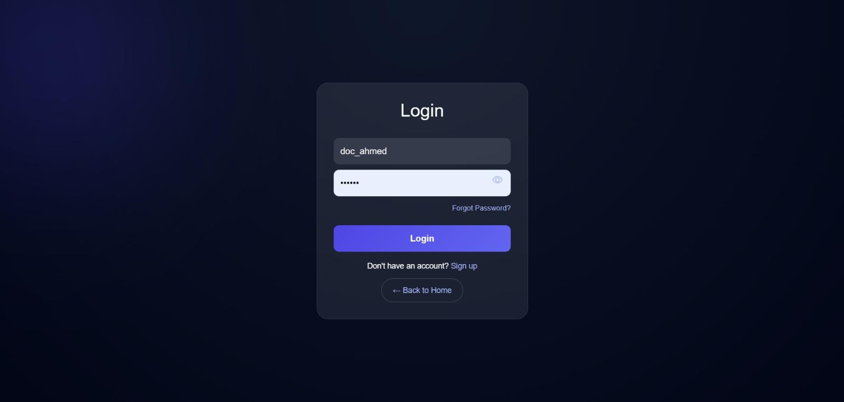
Figure 5.6.1: Login Page — The Login screen of the Docbot Website, featuring fields for username and password entry, a "Forgot Password" link, a "Login" button, and options to sign up or return to the home page.

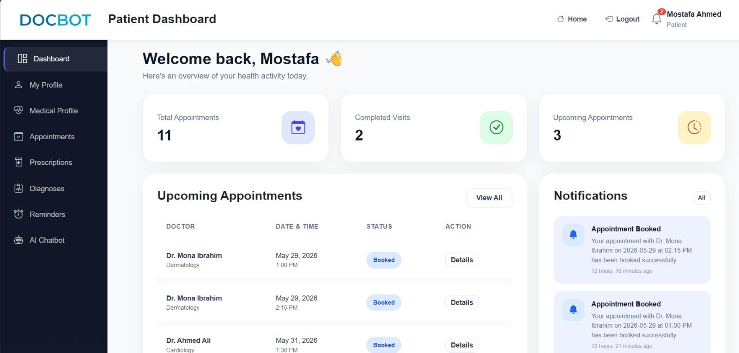

Figure 5.6.2: Patient Dashboard — The Patient Dashboard Page providing a personalized welcome message for the patient and a summary overview of metrics such as total appointments, completed visits, and upcoming appointments alongside a dedicated notifications panel.

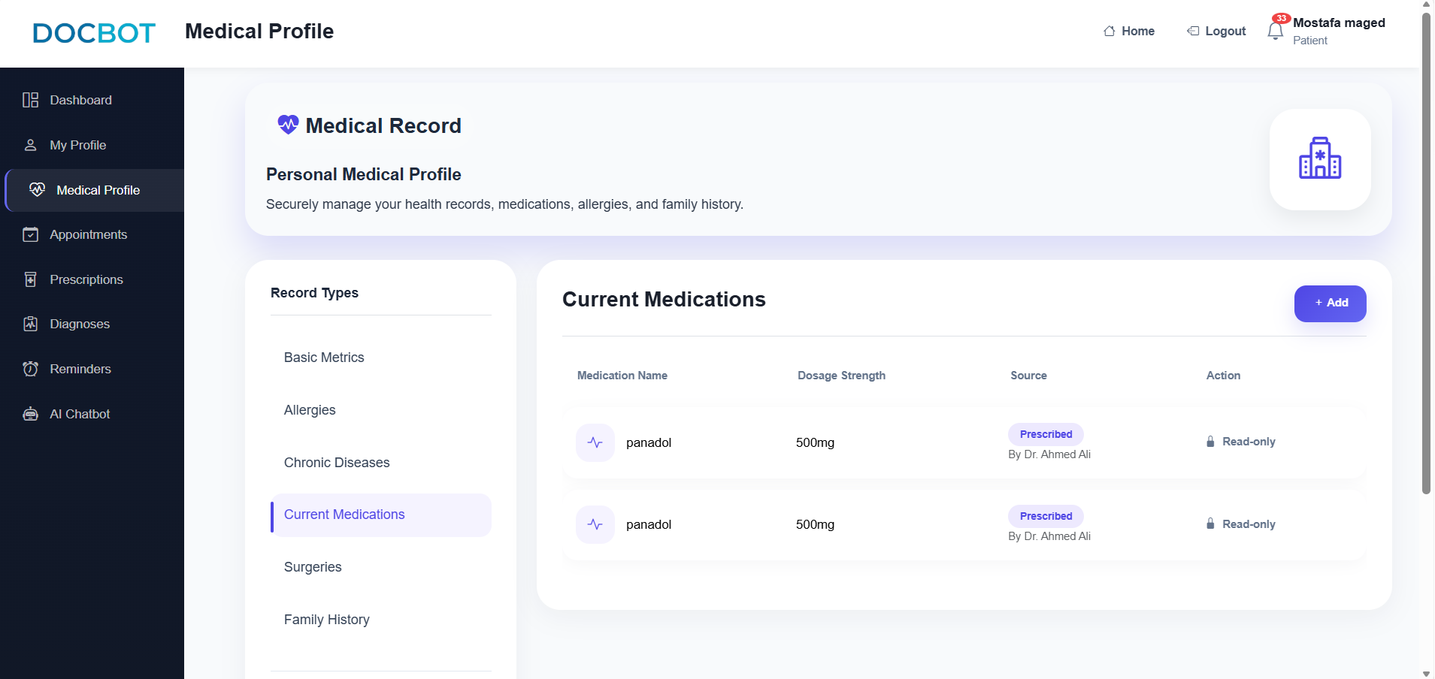
Figure 5.6.3 : Medical Profile Page — The Medical Profile Page of the DocBot Website, showcasing the "Chronic Diseases" module where a patient can view, add, or manage recorded conditions like Diabetes and Hypertension.

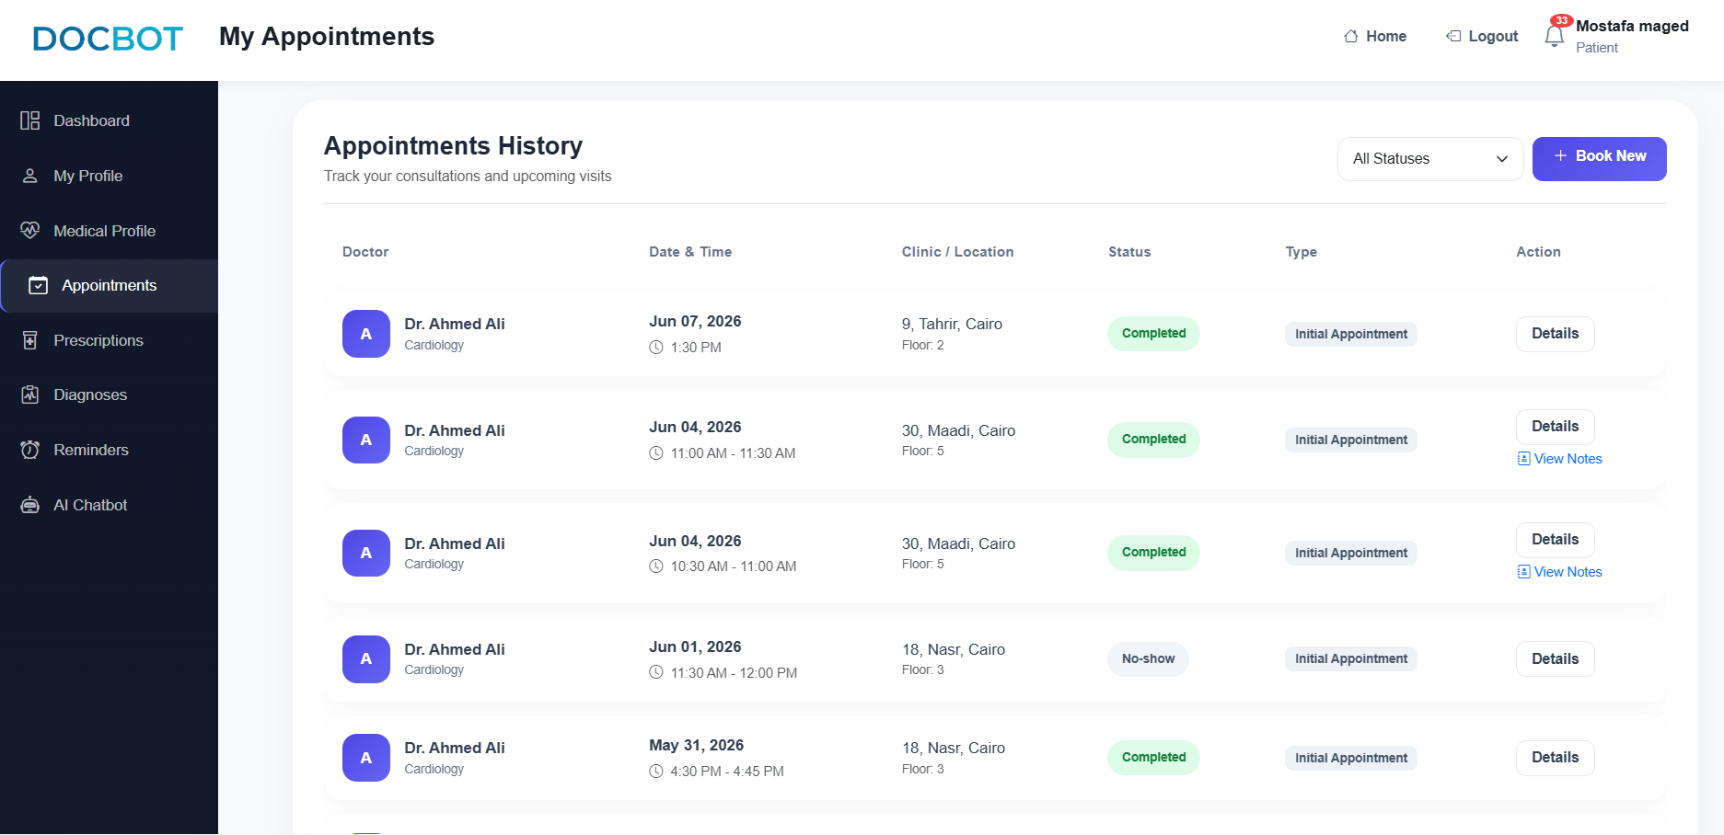

Figure 5.6.4: Appointments History Page — The Appointments History Page displaying the patient's Appointments History, which tracks scheduled medical consultations, their statuses (such as Booked, Canceled, or No-show), and clinic locations, along with an option to book a new appointment.

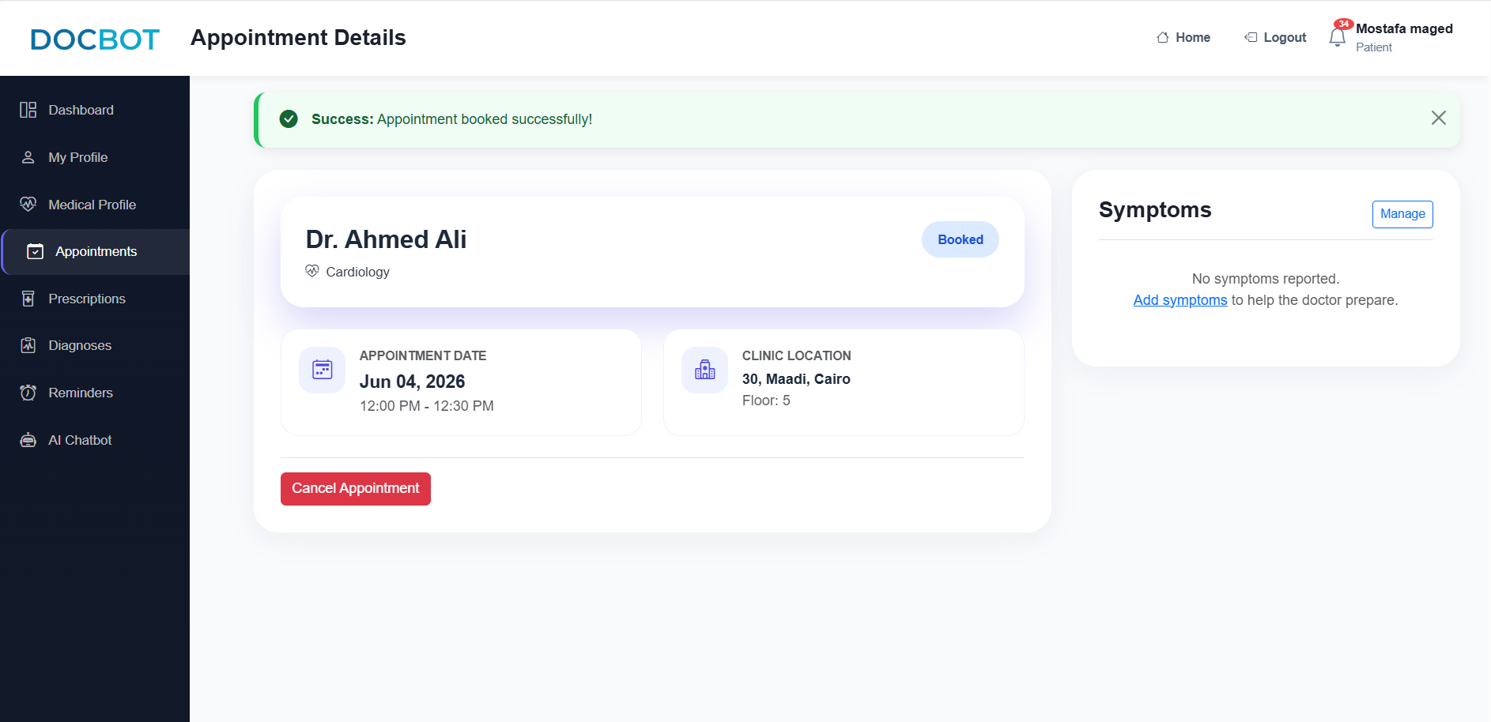

Figure 5.6.5: Appointment Details Page . The Appointment Details Page displaying a success banner for a successfully booked Appointment with Dr. Ahmed Ali, including the specific appointment date, clinic location, a "Cancel Appointment" action, and a section to manage symptoms.

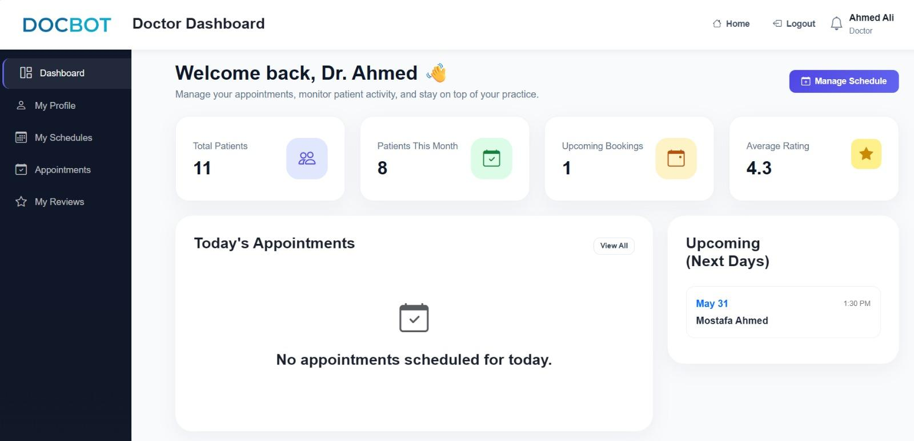
Figure 5.6.6 : Doctor Dashboard .The Doctor Dashboard Page provides a personalized welcome message for the doctor , displaying practice metrics such as total patients, upcoming bookings, and average rating, alongside panels for today's scheduled appointments and upcoming bookings for the next days.

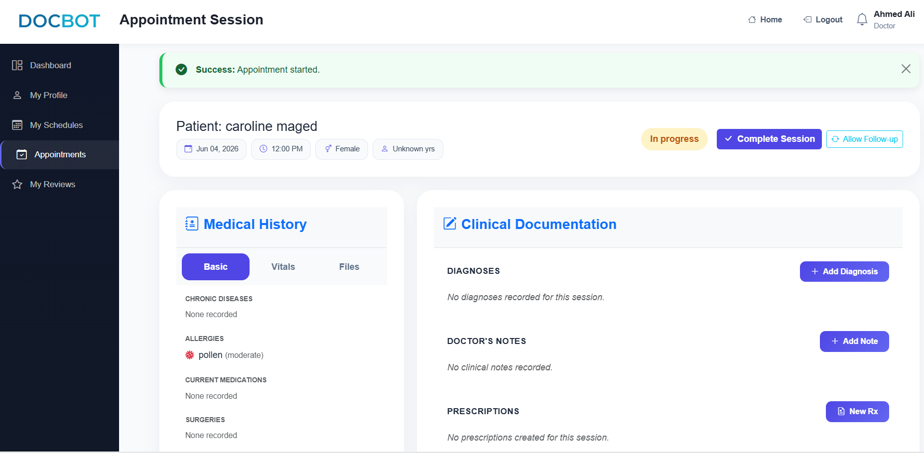
Figure 5.6.7 : Appointment Session Page .The Appointment Session Page showing an active, in-progress consultation for the patient , featuring a "Success: Appointment started" banner, access to the patient's medical history, and a clinical documentation area for recording diagnoses, doctor's notes, and new prescriptions.

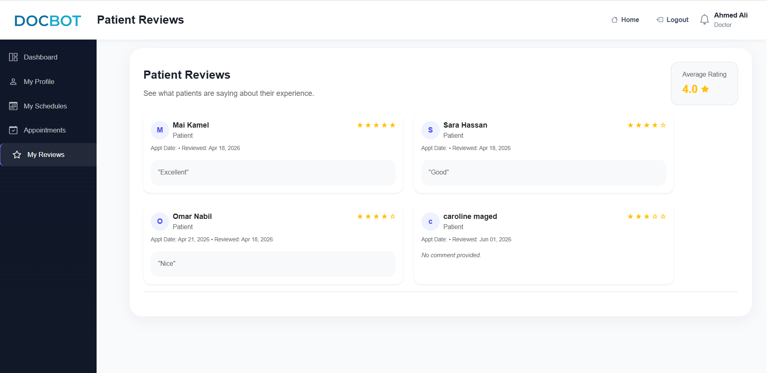
Figure 5.6.8 : Patient Reviews Page .The Patient Reviews Page displaying feedback from patients regarding their care experience, featuring a summary of specific patient comments, individual star ratings, appointment dates, and an aggregate average rating badge for the doctor.

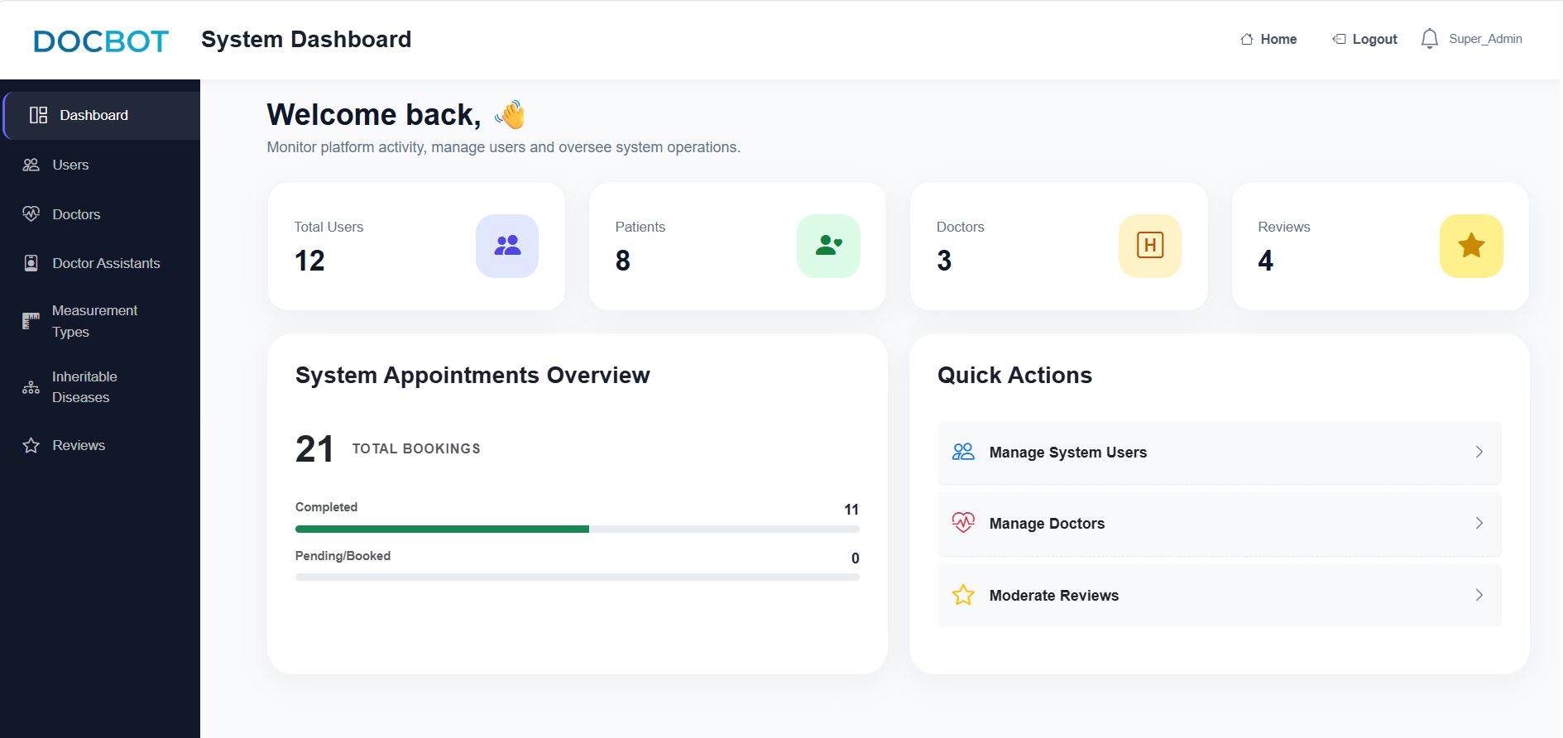
Figure 5.6.9 : Admin Dashboard .The Admin Dashboard Page providing an administrative overview for admin , displaying website metrics such as total patients, doctors, and reviews, along with a "System Appointments Overview" and a "Quick Actions" navigation menu.

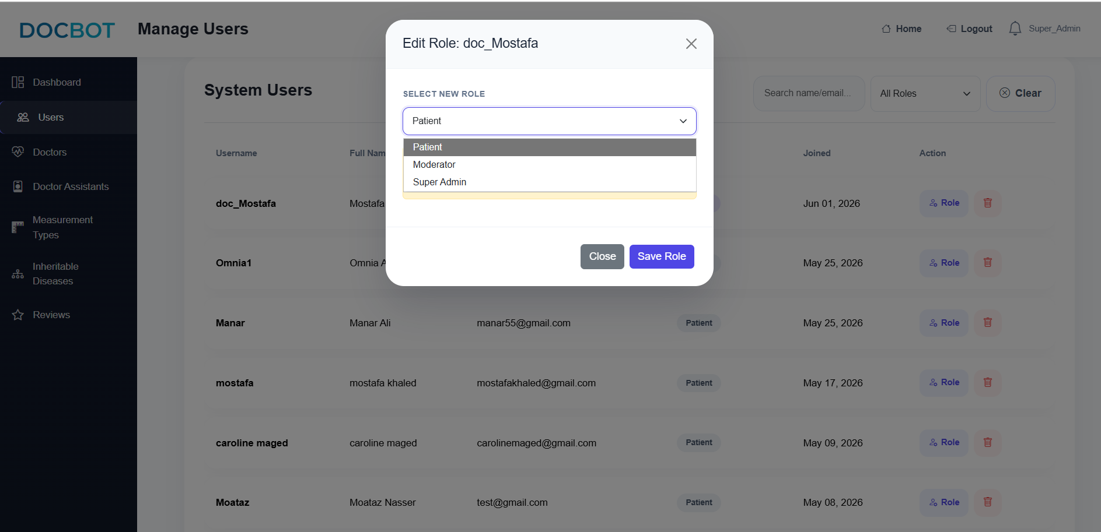
Figure 5.6.10 : Manage Users Page . The Manage Users Page displaying a "System Users" list with an active "Edit Role: mostafa" modal overlay, which allows an administrator to assign a new role to a user and displays a warning regarding systemic access changes.

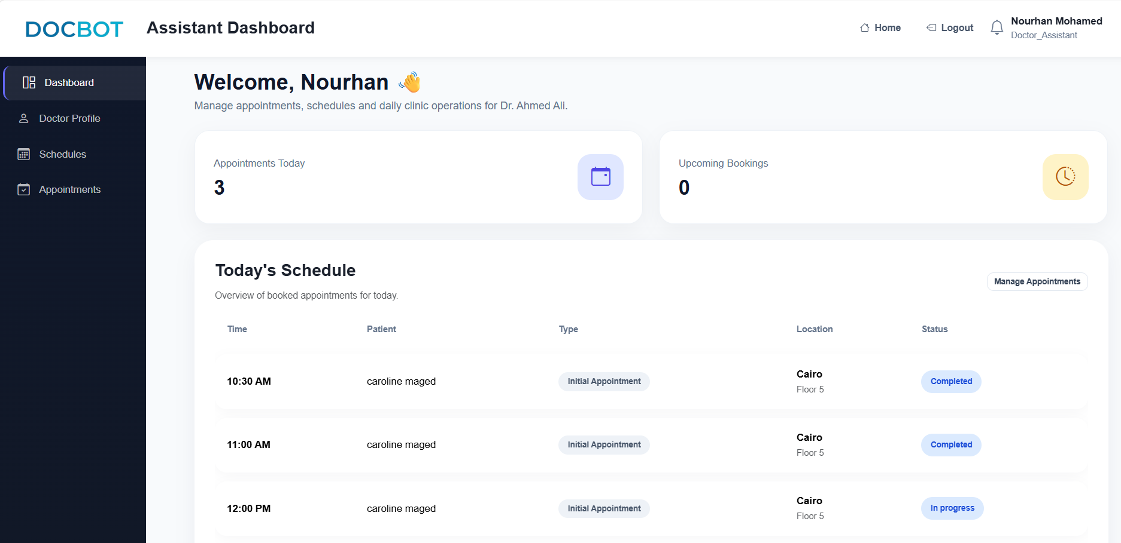

Figure 5.6.11: Doctor Assistant Dashboard — The Doctor Assistant Dashboard Page displaying a welcome message for the assistant indicating management of Dr. Ahmed Ali's clinic, along with metrics for today's appointments and upcoming bookings, and a "Today's Schedule" section tracking patient status.

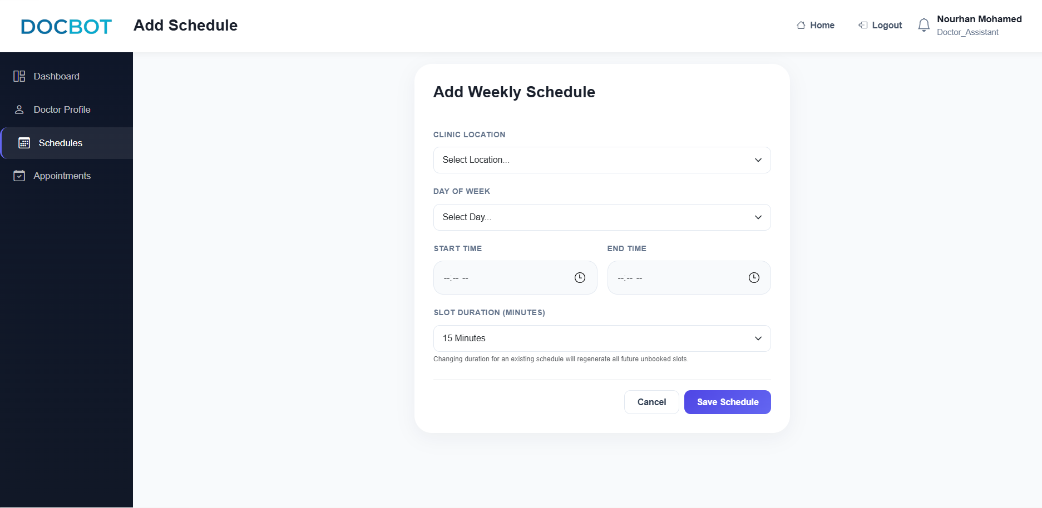

Figure 5.6.12 : Add Schedule Page — The Add Schedule Page displaying an "Add Weekly Schedule" form used to configure the doctor's appointment timetable, allowing the assistant to select the clinic location, day of the week, start and end times, and individual slot durations.

5.7 Challenges Encountered and Solutions

Challenge | Solution Adopted
Double booking of appointment slots by multiple patients | Implemented slot availability checks and automatically marked slots as booked immediately after appointment creation.
Doctors could potentially access clinical records before starting the appointment session. | Added appointment status validation and restricted record access until the session status changes to in progress.
Doctors might complete appointments without entering diagnoses or prescriptions. | Added backend validation to ensure diagnoses and prescriptions exist before allowing session completion.
Overlapping doctor schedules could lead to appointment conflicts. | Implemented schedule overlap detection before creating new schedules
Patients could attempt to book expired or unavailable time slots. | Filtered available slots based on current date, time, and booking status.
Invalid patient contact information could affect communication | Added validation rules for names, email addresses, phone numbers, and passwords.
Patients could book appointments without completing their medical profile, resulting in doctors having insufficient health information before consultations. | Implemented a pre-booking validation mechanism that checks whether the patient has completed their health profile. If the profile is incomplete, the system redirects the patient to the chatbot to finish providing the required medical information before appointment booking is allowed.

CHAPTER 6

Testing and Evaluation

6.1 Testing Strategy

6.2 Types of Testing Performed

6.2.1 Unit Testing

6.2.2 Integration Testing

6.2.3 System Testing

6.2.4 User Acceptance Testing (UAT)

6.2.5 Performance Testing

6.3 Test Cases and Results

6.4 Test Summary

6.5 Evaluation Against Requirements

6.6 Limitations and Known Issues

CHAPTER 7

7. Conclusion and Future Work

7.1 Summary of Work Done
This project has successfully delivered DocBot, a comprehensive, scalable, and "AI-ready" healthcare platform designed to bridge the critical execution gaps and eliminate health data fragmentation within the Egyptian medical ecosystem. By applying all phases of the Software Development Life Cycle (SDLC) in a professional framework, the development team has successfully transitioned the original conceptual proposal into a fully functional production-ready environment.
Revisiting the core objectives originally established in Chapter 1, the platform has achieved its clinical and technical goals to a high extent. First, an Intelligent Triage Chatbot was fully implemented utilizing branching logic to capture structured patient clinical histories through an interactive 13-question format, significantly minimizing human errors. Second, a unified, secure Electronic Health Record (EHR) database backed by MySQL and managed via a Django server was engineered to centralize isolated medical logs. Third, a highly user-friendly, intuitive, and properly formatted interface was designed and validated to ensure high usability for users of all technical skill levels. This responsive interface delivers the core functions of the user interface seamlessly, prioritizing "at-a-glance" navigation layouts and dynamic medical history filtering to enhance clinical decision-making and minimize administrative screen burdens for internal medicine specialists.
The primary deliverables completed and validated under this work include:
- The Software System: The complete deployment-ready software ecosystem utilizing a robust backend (Django), an automated workflow orchestration engine (n8n), and an economically optimized AI model.
- Comprehensive Documentation: A thorough structural analysis including data elicitation methodologies, formal stakeholder analysis, standardized UML designs (Class and Sequence diagrams), and a rigorous financial sensitivity analysis.

7.2 Key Findings and Lessons Learned

7.3 Comparison with Objectives

Objective | Status | Notes / Evidence of Achievement
Unify fragmented data & provide automated clinical intake. | Achieved | The core system is fully operational. Implemented a centralized relational database schema managed through Django ORM and MySQL to link isolated patient documentation seamlessly.
Implement an Intelligent Triage Chatbot. | Achieved | All planned conversational architecture features delivered. An interactive 13-question chatbot logic framework was deployed utilizing clinical branching rules via n8n orchestration.
Design a user-friendly interface. | Achieved | User interface deployment feedback was highly positive. Successfully delivered a responsive dashboard optimized for internal medicine specialists prioritizing at-a-glance information layout.
Ensure system reliability and safety through rigorous testing. | Achieved | Triage logic validation completed successfully. Achieved a comprehensive test execution criteria rate ensuring that high-risk cases and clinical red flags are identified early.
Apply all phases of the Software Development Life Cycle (SDLC). | Achieved | Delivered a scalable, production-ready platform. Executed disciplined agile development sprint bounds spanning from requirement elicitation and system architecture to final module integration.

7.4 Future Work and Recommendations
- Develop Native Mobile Applications
Create dedicated Android and iOS applications to improve accessibility, user engagement, and real-time healthcare support beyond the web and WhatsApp interfaces.
- Enhance AI-Powered Medical Assistance
Integrate more advanced AI and machine learning models for symptom analysis, personalized health recommendations, predictive risk assessment, and continuous patient monitoring.
- Personalized Health Continuity
Enhance the platform with long-term health tracking capabilities that utilize unlimited AI consultations to analyze patient health trends over time, provide personalized insights, and support more accurate monitoring and preventive healthcare.
- Family-Centric Care Features
Expand the platform with caregiver support functionalities, including Caregiver Alerts, medication reminders, appointment notifications, and family health monitoring to help users manage the healthcare needs of elderly parents and children.
- Professional Medical Report Portability
Develop exportable PDF medical reports and patient summaries that allow users to securely share their symptoms, consultation history, and healthcare records with medical professionals inside and outside the DocBot ecosystem.
- Expand Healthcare Ecosystem Integration
Connect the platform with hospitals, insurance providers, pharmacies, diagnostic laboratories, and national healthcare systems to provide a fully integrated digital healthcare experience.
- Strengthen Security and Privacy Measures
Implement Multi-Factor Authentication (MFA), OAuth 2.0 authentication, advanced encryption techniques, and compliance with healthcare data protection standards to enhance patient data security.
- Improve Scalability and System Architecture
Migrate to a microservices-based architecture and cloud-native infrastructure to support a larger number of users, healthcare providers, and concurrent consultations.
- Optimize Performance and Data Processing
Introduce caching technologies such as Redis and database optimization techniques to reduce response times and improve overall system performance under high workloads.
- Introduce Online Payment Integration
Integrate secure payment gateways to support subscription management, consultation payments, and future premium healthcare services directly through the platform.
- Expand Regional Market Coverage
Extend DocBot services across the Middle East and North Africa (MENA) region while supporting multilingual interfaces and localization requirements.
- Advanced Analytics and Reporting
Develop dashboards and analytical tools for healthcare providers to monitor patient trends, treatment outcomes, operational efficiency, and healthcare performance indicators.
- Real-time IoT Remote Monitoring: Continuous 24/7 vital sign tracking via wearable devices and IoT sensors is excluded from the current phase due to infrastructure costs.
- Fully Autonomous Diagnostic Model (Version 2.0): The transition from "provisional suggestions" to an advanced diagnostic model will only occur after collecting a sufficient volume of verified clinical data.
- Cross-Institutional Financial Settlement: Integration with national insurance payment gateways or universal health insurance billing systems.

7.5 Closing Statement
In conclusion, the development and deployment of the DocBot platform have provided an invaluable and transformative graduation project experience for the entire team. Moving beyond theoretical academic frameworks, this project challenged the team to operate as a structured, professional software engineering unit, navigating the complexities of healthcare systems analysis, full-stack database integration, and high-efficiency artificial intelligence orchestration within a real-world macroeconomic landscape.
Through managing complete Software Development Life Cycle (SDLC) sprint bounds and aligning technical deliverables with data privacy regulations, the team has successfully demonstrated its readiness for the professional software and information systems industry. The core capabilities cultivated throughout this journey—spanning from requirement elicitation and system architecture to complex variable financial costing and agile coordination—have effectively equipped each team member with the interdisciplinary expertise required to analyze market gaps, engineer scalable digital solutions, and contribute meaningfully to the evolving landscape of digital transformation and tech-driven enterprises.
Appendix A: Project Proposal (Initial Proposal Document)
Project Title
Toward Unifying Medical Health Records in Egypt: Assessing the Problem of Health Data Fragmentation and Integration Policies
"DocBot"
Team Members:
- Ahmed Hamdi Samir
- Caroline Maged Phillip
- Fatima Elzhraa Ashraf Mohamed
- Fatma Nasser Saed
- Mai Kamel Abd EL-Rahim
- Moataz Nasser Mahmoud
- Rania Diaa Mohamed
- Rawan Mostafa Kamal
- Rwan Osama Yoseef
- Sohyla Ahmed Mahmoud Salah Eldin
- Yahia Eid Hassen

Problem Statement
Despite national efforts toward digital transformation, the Egyptian healthcare landscape suffers from a critical absence of automated clinical intake tools capable of bridging the gap between patient history and clinical decision-making (Alorbany et al., 2025). Currently, patients must rely on their memory during consultations because their medical information remains scattered across disconnected systems (Stroetmann, 2009). This lack of standardized, structured reporting leads to several key issues:
- Clinical Risks: Fragmented records directly increase the risk of preventable medical errors and treatment delays (Stroetmann, 2009).
- Operational Inefficiency: Physicians face administrative burdens and burnout due to manual data entry and redundant medical testing (Auld, 2024).
- Economic Waste: Patients frequently repeat expensive diagnostic tests and receive conflicting prescriptions due to the lack of a reliable, unified medical history (The World Bank, 2021).
- Diagnostic Accuracy Gap: Existing foreign symptom-checkers often lack the contextual nuance required for local clinical protocols, achieving significantly lower accuracy compared to specialists (Alorbany et al., 2025).
DocBot addresses this problem by implementing a logic-based AI engine that performs intelligent history taking, symptom processing, and smart routing, ensuring that every patient arrives at the clinic with a detailed, timeline-based medical record (Alorbany et al., 2025).
Proposed Solution
DocBot is an AI-powered healthcare platform designed to improve patient care and streamline healthcare services through intelligent automation and digital health management. The platform provides an AI chatbot assistant for symptom assessment, maintains comprehensive patient medical histories, recommends the appropriate medical specialty, and supports healthcare providers through dynamic Electronic Health Records (EHR). In addition, DocBot integrates laboratory data, manages medication reminders and adherence tracking, and facilitates efficient communication between patients and healthcare providers. By combining artificial intelligence, centralized medical records, and workflow automation, DocBot aims to enhance diagnostic accuracy, reduce administrative burden, and improve the overall healthcare experience.
This project aims to achieve the following objectives:
- Develop a fully functional AI-driven ecosystem to unify fragmented patient data and provide automated clinical intake.
- Implement an Intelligent Triage Chatbot to address the gap in standardized history-taking and minimize human error through structured, branching question formats.
- Design a user-friendly interface that meets the needs of both patients and internal medicine specialists, prioritizing "at-a-glance" information for clinical efficiency.
- Ensure system reliability and safety through rigorous testing of triage logic to minimize "under-triage" risks and ensure high-risk cases are identified early.
- Apply all phases of the Software Development Life Cycle (SDLC) in a professional manner to deliver a scalable, "AI-ready" healthcare platform.
Expected Outcomes
The DocBot system is expected to make healthcare more simple, organized, and accessible by improving how patients and doctors interact with medical data and services. It aims to replace fragmented and manual processes with a more connected and AI-supported healthcare experience.
First, the system is expected to improve the accuracy of early symptom checking, as the chatbot helps guide patients through structured questions and highlights possible high-risk cases earlier.
Second, it will help doctors and healthcare providers by keeping all patient information in one place through a centralized Electronic Health Record (EHR), making it easier and faster to review medical history.
Third, DocBot is expected to reduce the workload on doctors and clinics by automating patient data collection, summaries, and basic assessments, allowing more time for actual medical care.
Fourth, it will improve patient engagement and follow-up, especially through features like medication reminders and continuous interaction with the system, helping patients stay more consistent with their treatment.
Finally, the system is designed to be a strong base for future growth, allowing the addition of more advanced features like predictive analytics and hospital integrations as the platform expands.

Appendix J: Detailed Feasibility Study Report
Project Version: 1.0 Date: February 2026
1. EXECUTIVE SUMMARY
This report evaluates the technical and economic viability of an integrated healthcare platform centered on a unified Electronic Health Record (EHR) and an AI-driven triage system (Alorbany et al., 2025). The project utilizes a high-efficiency technology stack (Django, n8n, MySQL) and top-tier LLMs (Grok, GPT-4, Claude) to bridge the gap between patient intake and clinical diagnosis (Wang et al., 2018). Based on the 2026 Egyptian market benchmarks and legal landscape, the project is deemed highly feasible with a fast path to operational break-even.

2. TECHNICAL FEASIBILITY
2.1 System Architecture & Tech Stack
The system is built on a robust, scalable architecture:
• Backend Engine: Django (Python). Chosen for its high-security standards and superior handling of medical data structures.
• Frontend Interface: Modern HTML5, CSS3, and JavaScript, optimized for web and mobile.
• Data Management: MySQL (Relational Database) is designed for standardized EHR protocols.
• Logic Orchestration: n8n (Self-hosted). Acts as the workflow engine connecting the backend to AI models.
2.2 AI Triage & Data Extraction
• Interaction: A 13-question interactive diagnostic agent that collects patient history.
• Extraction: LLMs parse unstructured text into JSON schema (Symptom, Duration, Urgency) for direct injection into the database.
• Verification: All AI-extracted data is verified by the physician during the physical appointment.
2.3 Infrastructure & Security
- Hosting: Ubuntu 24.04 Cloud Server hosted via Network EGYPT. This ensures Data Residency compliance with Egyptian Law 151/2020 (Egyptian Parliament, 2020).
- Domain: A professional .com TLD, providing global accessibility and brand credibility.
- Security: SSL/TLS encryption, weekly automated backups, and AES-256 encryption at rest.

3. ECONOMIC FEASIBILITY

3.1 Capital Expenditure (CAPEX) - Team Labor Value
Based on 2026 Junior-level salary benchmarks in Egypt for an 8-month cycle (Paylab Egypt, 2026):
Labor costs represent the estimated market value of development effort rather than direct cash expenditure.
Role (11 Members) | Avg. Monthly Salary (EGP) | Total Value (8 Months)
Backend (4 devs) | 22,000 | 704,000 EGP
Frontend (3 devs) | 18,000 | 432,000 EGP
Database (2 devs) | 20,000 | 320,000 EGP
Automation (2 devs) | 20,000 | 320,000 EGP
TOTAL LABOR VALUE |  | 1,776,000 EGP

Regulatory Compliance Costs (Sensitive Data collecting& processing License & DPO Setup): 50,000 EGP (Egyptian Parliament, 2020).
Total Initial Capital Investment (Year 0 Outflow ): 1,826,000 EGP (1,776,000 + 50,000).

3.2 Monthly Operational Expenditure (OPEX) & Gradual Scaling Strategy:
To optimize operational efficiency, the platform separates immediate cash-out operating expenses (Hosting, Domain, and AI APIs) from long-term capital amortization.
3.2.1 Baseline Monthly Fixed Cash Expenses
These are the minimum running costs required to keep the platform online, regardless of user traffic:
· Cloud Hosting (Network EGYPT - Ubuntu): 986 EGP / month
· Domain Registration (.com TLD): 67 EGP / month (800 EGP annually / 12 months)
Total Base Fixed Expenses: 1,053 EGP / month
Operational costs are expected to increase gradually with user growth and infrastructure scaling requirements.
Detailed AI Model Cost Breakdown:
To evaluate the variable operational cost of the triage system, the financial model assumes an average session requirement of 6,000 total tokens per patient interaction (split into 5,000 Input Tokens for prompts/clinical guidelines and 1,000 Output Tokens for unstructured data parsing and JSON payload generation)
All calculations are executed under a framework assuming a cache-miss scenario (zero data caching) to reflect maximum potential cost exposure, computed at a standard currency exchange rate of 50.00 EGP / USD.
1. DeepSeek-V4-Flash
· Global API Pricing: Input: $0.14 / 1M Tokens , Output: $0.28 / 1M Tokens
Calculations:
Unit cost = [(5000 * (.014/1000000)) + (1000 * (.028/1000000))] * 50 = 0.0490 EGP
Pilot Phase Total (200 Users/Month):0.0490 * 200 = 9.8 EGP/Month
Total Monthly base OPEX Integration: 9.8 EGP(AI) +1.053 EGP(Base Fixed Hosting + Domain) = 1062.8 EGP

2. Grok 4.3
· Global API Pricing: Input: $1.25 / 1M Tokens , Output: $2.5/ 1M Tokens
Calculations:
Unit cost = [(5000 * (1.25/1000000)) + (1000 * (2.5/1000000))] * 50 = 0.4375 EGP
Pilot Phase Total (200 Users/Month): 0.4375 * 200 = 87.5 EGP/Month
Total Monthly base OPEX Integration: 87.5 EGP(AI) +1.053 EGP (Base Fixed Hosting + Domain) = 1140.5 EGP

3. GPT-4o
· Global API Pricing: Input: $2.50 / 1M Tokens , Output: $10.00 / 1M Tokens
Calculations:
Unit cost = [(5000 * (2.5/1000000)) + (1000 * (10/1000000))] * 50 = 1.125 EGP
Pilot Phase Total (200 Users/Month): 1.125 * 200 = 225 EGP
Total Monthly base OPEX Integration:
225 EGP(AI) +1.053 EGP(Base Fixed Hosting + Domain) = 1278 EGP

4. Claude 4.5 Sonnet
Global API Pricing: Input: $3.00/ 1M Tokens , Output: $15.00 / 1M Tokens
Calculations:
Unit cost = [(5000 * (3.00/1000000)) + (1000 * (15.00/1000000))] * 50 = 1.5 EGP
Pilot Phase Total (200 Users/Month): 1.5 * 200 =300 EGP
Total Monthly OPEX Integration: 300 EGP(AI) +1.053 EGP(Base Fixed Hosting + Domain) = 1353 EGP

Comparison summary
AI Model Option | Unit Cost / Patient (EGP) | Total Variable AI Cost (200 Users) | Base Fixed Cost (Host+Domain) | Total Monthly Cash OPEX
DeepSeek-V4-Flash | 0.0490 EGP | 9.80 EGP | 1,053.00 EGP | 1,062.80 EGP
Grok 4.3 | 0.4375 EGP | 87.50 EGP | 1,053.00 EGP | 1,140.50 EGP
GPT-4o | 1.1250 EGP | 225.00 EGP | 1,053.00 EGP | 1,278.00 EGP
Claude 4.5 Sonnet | 1.5000 EGP | 300.00 EGP | 1,053.00 EGP | 1,353.00 EGP

Based on the comparative matrix, DeepSeek-V4-Flash is officially selected as the core MODEL triage and unstructured data processing engine for the DocBot platform.
Economic Justification:
- Unparalleled Margin Optimization: At a variable cost of just 0.0490 EGP per patient interaction, DeepSeek-V4-Flash reduces API computational overhead by 88.8% compared to Grok 4.3 and 95.6% compared to GPT-4o. This structural cost elimination directly translates into a near-maximum Net Marginal Contribution of 49.951 EGP out of the 50.00 EGP transaction commission charged to clinics.
- Mitigation of Financial Risk: During the initial pilot validation phases where transaction volumes are low, the total API expense for a cohort of 200 users is practically negligible (9.80 EGP/month). This eliminates high operational cash-burn risks while retaining full JSON-schema compliance and clinical response reliability.

3.2.2 Scalable OPEX & Infrastructure Expansion Strategy
To ensure the platform's long-term financial viability without introducing high operational cash-burn risks during the initial stages, the financial framework deploys a Self-Funding Infrastructure & Growth Strategy. The operational expenditure logic is systematically structured across two main execution phases:
- Pilot Validation Phase (Year 1): During this initial entry market phase, the platform operates on minimal running costs (Baseline Hosting and Domain Registration) due to low early-stage traffic. To maintain a near-zero Customer Acquisition Cost (CAC), the development team will directly manage B2B sales and physician onboarding in Assiut through organic outreach and localized networks, eliminating early direct marketing expenditures.
- Commercial Scaling & Institutional Phase (Years 2 & 3): As transaction and booking volumes scale , the platform will systematically dynamic-allocate a 10% operational reserve from the 50 EGP commission collected per completed appointment (equivalent to 5 EGP per transaction). This dynamic transaction-driven revenue allocation will automatically fund and absorb the following critical operational scaling sub-components:
  - Automated Cloud Scaling & Database Maintenance: To seamlessly manage increased user traffic and expanded Electronic Health Record (EHR) database storage.
  - Communication & Notification Gateways: To cover the scalable cost of SMS, Emails, API triggers, and real-time patient-physician notification alerts.
  - Digital Marketing & Acquisition Campaigns: To fuel ongoing regional expansion, boost platform brand credibility, and acquire new medical provider networks across Egypt.

3.3. Commercial Gradual Scaling & Revenue Forecasting (Years 1–3):
To transition DocBot from an academic prototype into a commercially viable enterprise, the financial framework rejects static volume assumptions and deploys a Gradual Scaling Strategy over a 36-month horizon. This model systematically expands the medical provider network across Egypt to recover the initial 1,826,000 EGP Capital Investment (comprising 1,776,000 EGP capitalized development labor + 50,000 EGP estimated regulatory and compliance cost).
The platform generates revenue through a 50 EGP commission per completed appointment. The commission is charged only after successful patient attendance and consultation completion. This pricing is aligned with the average private-clinic consultation fees in Assiut (250–500 EGP), representing approximately 10–20% of the consultation value.

3.3.1Financial Sensitivity Analysis & Market Scenarios
Market Scenario | Expected Monthly Bookings (Year 3) | Projected Annual Revenue | Strategic & Financial Implication
Conservative | 1,500 Bookings / Month | 900,000 EGP | Proves the platform's high resilience; comfortably clears the break-even point, covers all fixed costs, and maintains healthy baseline profitability even under slow market adoption.
Moderate | 3,000 Bookings / Month | 1,800,000 EGP | Reflects a highly realistic, organic market penetration across Upper Egypt, ensuring a stable and rapid payback period.
Optimistic | 5,000 Bookings / Month | 3,000,000 EGP | Represents the fully realized institutional scaling tier, establishing market leadership in Assiut and capturing the target market share.
To safeguard the project's financial planning against market volatility and fluctuation in physician adoption rates, the financial framework rejects single-variable forecasting. The revenue model presented in this study is strategically anchored on the Optimistic Target Scenario to analyze the platform's maximum capacity and scalability. However, to demonstrate academic and financial maturity, a Sensitivity Analysis has been conducted to outline three alternative operational tracks for Year 3 performance:
Formulas used:
· Annual Revenue = Average Monthly Bookings * 12 Months * 50 EGP commission
· Operational Expense (OPEX) Formula = Annual Base Fixed Expenses (12636 EGP ) + (Annual Total Transactions * .0490 EGP “Deepseek API cost”)
Year 1: Pilot Deployment & Market Entry:
Operational Metric: Achieving an average of 200 successful bookings per month across a core group of early-adopter physicians in Assiut
Total Transactions: 2,400 bookings/year.
Gross Revenue: 200 * 12 * 50 = 120000 EGP
Direct Operating Cash Cost: 12636 +(2400 * 0.0490) = 12754 EGP
Net Cash Flow (NCF1) = 120000 – 12754 = 107246 EGP

Year 2: Regional Scaling and Market Penetration:
Operational Metric: Scaling the platform network to 35 active private clinics, with each provider averaging just 1 booking per day via DocBot (averaging 2,000 total platform bookings per month).
Total Transactions: 24,000 bookings/year.
Gross Revenue: 2000 * 12 * 50 = 1200000 EGP
Direct Operating Cash Cost: 12636 +(24000* 0.0490) = 13812 EGP
Net Cash Flow (NCF2) = 1200000 – 13812 = 1186188 EGP

Year 3: Market Expansion:
Operational Metric: Expanding the footprint to a mature institutional tier, averaging 5,000 successful bookings per month via clinics.
Total Transactions: 60000 bookings/year.
Gross Revenue: 5000 * 12 * 50 = 3000000 EGP
Direct Operating Cash Cost: 12636 +(60000* 0.0490) = 15576 EGP.
Net Cash Flow (NCF3) = 3000000 – 15576 = 2984424 EGP

4.Investment Valuation Metrics:

4.1 Net Present Value (NPV)
NPV calculates the current net value of all future cash inflows generated by the platform minus the initial capital investment (I_0 = 1,826,000 EGP)
NVP= - I_0 + (NCF_1/(1+r)^1) + (NCF_2/(1+r)^2) + (NCF_3/(1+r)^3)
NVP = - 1826000 +(107246/(1.15)^1) + (1186188 /(1.15)^2) + (2984424/(1.15)^3) = 1,126,492.84 EGP
Because the NPV is positive, the project is viable and guarantees to generate significant net wealth above its total capitalization costs.
1.2 Return on Investment (ROI):
ROI measures the absolute efficiency of the initial invested capital over the 3-year performance cycle:
ROI = ((Total 3-Year Net Inflow /Initial Capital Expenditure ) * 100%
ROI = ((4,277,858 / 1,826000) * 100% = 234.27 %
1.3 Break-even point:
Total Base Fixed Expenses: 1,053 EGP / month
Capitalized Team Labor Amortization:(1,776,000 /36 Month)= 49333.3 EGP /Month
Regulatory Compliance Cost Amortization:(50000/36 Month) = 1388.89 EGP/Month
Totally adjusted fixed cost= 1053 + 49333.33 + 1388.89 = 51775.22 EGP/Month
Net Margin contribution per booking = 50 – 0.0490 = 49.951 EGP
Q = (Totally adjusted fixed cost/ Net Margin contribution per booking) =
51775.22/49.951 = 1037 bookings/ month
The capitalized team labor amortization (49333.33 EGP/Month) is integrated into the break-even framework as a theoretical, non-cash accounting allocation. This is executed solely to evaluate the long-term economic sustainability of the platform, rather than representing an actual physical cash outflow during the initial operational phase
4.4 Payback period:
Payback Period: 2.12 Years (approximately 25 months).

5.Pricing Strategy
1. Market Segmentation
Segment A: Individual Patients (B2C)
- Focus: Free access to immediate risk assessment (Triage) and a structured and comprehensive Electronic Health Record (EHR).
Segment B: Healthcare Providers/Clinics (B2B)
- Focus: Improving clinical workflow efficiency by providing a structured and comprehensive Electronic Health Record (EHR) that is ready for use, while reducing human diagnostic errors and saving time.

2. Detailed Revenue Models
The Freemium Model (Patient Side)
- The Free Tier (Core Services):
  - AI Triage Chatbot: symptom checking and emergency risk assessment (Triage).
  - Clinical Referral: If the AI identifies urgent or specific symptoms, the patient is immediately prompted to book an appointment with a verified specialist through our platform.
  - Automated EHR Synchronization: Upon booking, the patient’s unified medical record (EHR) and the chatbot’s triage summary are automatically shared with the selected doctor
  - Lifetime EHR: Personal digital storage for all medical history, diagnoses, and prescriptions.
  - Smart Reminders: Automated medication and follow-up appointment alerts.

- The Premium Tier (Future Value-Add):
- Model: Monthly subscription Fee.
- Fee Structure: A recurring subscription fee of 199 EGP per month
- Value Proposition:
  - Personalized Health Continuity: With unlimited AI consultations, patients gain a deeper understanding of their health trends over time, allowing for more precise monitoring without usage barriers.
  - Family-Centric Care: The "Caregiver Alert" feature bridges the gap between generations, ensuring that elderly parents or children never miss a dose or an appointment, providing the account holder with ultimate peace of mind.
  - Professional Portability: Exportable Symptom PDF Reports transform digital data into a professional medical document that can be shared globally, ensuring the patient’s clinical history is always accessible, even outside the platform’s network.

The Value-Based Commission Model (Doctor Side)
- Model: Transactional Success Fee .
- Fee Structure: A variable commission ranging from 10% to 20% depending on the doctor's appointment fee, designed to generate an average commission of approximately 50 EGP per successful booking.
- Value Proposition:
1. Clinical Efficiency: Doctors receive the patient’s "Pre-filled EHR" and triage summary before the visit, reducing administrative time .
2. Zero Risk: Clinics pay only for confirmed arrivals, making the platform a cost-effective marketing and management tool.
3. Optimizing Follow-up Visits: Through automated follow-up reminders, the platform maintains continuous engagement between patients and their clinics. This substantially increases patient return rates for medical reviews, ensuring a steady and sustainable flow of confirmed consultations for the clinic.
3. Pricing Rationale and Logic
· Value-Based Logic: The commission is priced based on the time saved for doctors . By automating the history-taking phase through the chatbot, administrative minutes are converted into revenue-generating clinical time through direct patient care.
· Data-Centric Logic: Since the platform’s primary asset is aggregated EHR, patient usage is priced at zero (Core Services) to ensure a strong “Network Effect,” where an increasing number of users enhances the value of generated insights and analytics. This also supports user acquisition and maximizes platform adoption.
· Psychological Thresholds and Conversion Optimization (Premium Tier): The selection of a 199 EGP monthly subscription fee for the Premium Tier was carefully calibrated to align with consumer psychological price thresholds within the current Egyptian macroeconomic landscape. This approach positions the service as an affordable, high-utility micro-transaction. By embedding features that simultaneously address human and operational needs—such as the "Caregiver Alert" for family health security and unlimited AI-driven medical consultations—the platform ensures that the perceived value exponentially outweighs the nominal fee. This directly drives user conversion from the free tier to a recurring, permanent subscription.
· Market Benchmarking: A commission range of 10%–20% is considered competitive within the Egyptian digital health market when benchmarked against existing platforms. However, the proposed system offers significantly enhanced value at the same price range, as it integrates advanced AI-driven features, unified Electronic Health Records (EHR), and continuous patient monitoring capabilities, thereby providing a substantially higher service value without increasing the cost burden on users.
4. Competitive Benchmarking
To establish a sustainable and market-penetrating pricing model for DocBot, a rigorous competitive benchmarking analysis was conducted against primary regional health-tech players in the Egyptian and MENA ecosystems. This benchmark evaluates competitors across four strategic dimensions: primary revenue architecture, artificial intelligence integration capabilities, Electronic Health Record (EHR) structural depth, and strategic data utilization.
Platform | Primary Model | AI Integration | EHR Depth | Data Usage
Our Platform | Hybrid (Freemium + Commission) | AI Triage Chatbot (Free Included) | Full Clinical History | Clinical Insights
Yodawy | Commission from pharmacies and insurance | Insurance automation | Prescription and Insurance Data | Operational ,Delivery Data
Vezeeta | Commission Based Booking and Subscriptions | Search and Patient Routing | Clinic-Based Records | Booking and patient flow Optimization
Altibbi | Subscriptions + Paid Consultations | AI Assistant | Consultation History + Basic EMR | Clinical Data and AI Improvement
Shefaa | Commission-based (Pharmacies/Labs) + Subscriptions | Medication adherence and Reminder automation | Prescription and Medication History | Demand Prediction and Adherence Patterns
Anees Health | Subscription-based (Care Bundles for Families/Elderly) | AI Assistant | Chronic vitals tracking + Caregiver logs | Longitudinal Health Monitoring Data

5. Operational and Billing Policies
- No-Show Policy: Instead of pre-payments, we implement a User Credibility Score. Patients with repeated missed appointments receive a warning, and in case of continued no-shows, a temporary suspension (ban) of 20 days is applied. This policy is designed to protect doctors' schedules.
- Billing and Settlement: All doctor commissions and Premium subscription fees are settled monthly via Digital Wallets or Instapay. Premium features are immediately deactivated if the subscription is not renewed by the end of the billing cycle.
- Refund Policy: All payments for Premium features are non-refundable, ensuring the sustainability of digital service delivery.
- Contract Termination (Provider Side): Doctors wishing to terminate their contract must provide a 7 to 14-day notice period. Termination becomes effective only at the end of the month to ensure full commission reconciliation for that period.
- Data Offboarding: Upon termination, access to the platform’s integrated EHR database is revoked.
- Forced Termination (Breach of Conduct): The platform reserves the right to terminate contracts immediately for non-payment, ethical breaches, or unjustified appointment cancellations. Final dues will be collected at the end of the month, and legal action will be pursued in case of non-settlement.

6. Scalability and Future Roadmap
· Short-Term: Market Leadership and Data Foundations
Dominate the patient-doctor connection market and establish the most comprehensive, structured EHR database in the region to serve as the primary engine for all platform operations.

· Mid-Long Term: Data Monetization , AI Evolution and Premium Subscription Tier Activation

1. Activation of Premium Subscription Tier (199 EGP/month): Launching a value-added membership for advanced patient empowerment, featuring unlimited AI consultations, "Caregiver Alert" for family-centric monitoring, and Professional Portability through exportable clinical history reports.
2. Monetizing Aggregated and Anonymized Data Insights : Providing pharmaceutical companies and policymakers with statistical trends on public health (e.g., disease prevalence) without compromising individual privacy.
3. AI Model Refinement: Continuously improving the diagnostic support and predictive AI models using the accumulated large-scale clinical data to achieve higher accuracy and specialized medical insights.

· B2B Integration
Building a Unified Health Ecosystem, integrating key healthcare partners through:
1. Introduction of Laboratory Partners through Medical Bundles: The platform will collaborate with accredited laboratories to design and offer exclusive diagnostic bundles tailored to users’ healthcare needs. These bundles will be purchased from partner laboratories at discounted rates and offered to patients through the platform. Revenue will be generated through a profit margin on each bundle sold, creating a scalable and transaction-based income stream. This model benefits laboratories by expanding their patient reach and increasing testing volumes, while patients receive high-quality diagnostic services at reduced costs.
2. Pharmacies: Automated prescription routing and instant medication dispensing.
3. Hospitals and Insurance Providers: Seamless data exchange and automated claims processing, ensuring a fully integrated journey for the patient from diagnosis to recovery.
Appendix K : Business Plan
Company Summary:
DocBot is an AI-powered healthcare platform designed to improve the patient journey by providing smart, accessible, and efficient medical support. The platform begins with AI based symptom analysis that helps patients better understand their health conditions and guides them toward the appropriate medical action. In addition, DocBot supports appointment management, patient communication, and continuous follow-up to enhance healthcare efficiency and reduce pressure on healthcare providers. Our mission is to provide comprehensive smart healthcare that starts with AI symptom analysis and ends with continuous follow-up, ensuring an error-free patient journey.
How will your company be organized?
DocBot will be managed by the project’s founding team through a structured leadership model that ensures efficient decision-making and operational management. The company will include key executive roles such as the Chief Executive Officer (CEO), Chief Operating Officer (COO), Chief Technology Officer (CTO), and Chief Commercial Officer (CCO). Under these leadership positions, specialized teams will operate across technology development, AI systems, operations, marketing, customer support, and business development. The company’s structure is designed to encourage innovation, collaboration, scalability, and a strong commitment to improving healthcare experiences through technology.
Opportunity :
Egypt’s healthcare system is losing millions annually due to fragmented patient data, inefficient care delivery, and a heavy reliance on out-of-pocket spending. With a population exceeding 110 million and a rapidly increasing burden of chronic diseases, the market presents a compelling multi-billion-dollar opportunity for scalable digital health solutions. 1. Broken Data Ecosystem Healthcare providers across Egypt largely depend on paper-based records, resulting in incomplete, inconsistent, and often inaccessible patient histories. According to WHO regional estimates, up to 40% of critical patient data is lost due to poor documentation practices [1]. This fragmentation leads to misinformed clinical decisions, repeated diagnostics, and inefficient patient journeys—creating a clear demand for interoperable, cloud-based solutions like DocBot. 2. A System Ready for Digital Transformation Despite limited adoption of Electronic Health Records (EHRs), Egypt is undergoing a major healthcare transformation. Government initiatives such as Vision 2030 and the Universal Health Insurance System (UHIS) are actively pushing providers toward digitization [2]. This creates a strong regulatory tailwind and a significant gap for plug-and-play platforms that can seamlessly integrate into existing workflows—positioning DocBot as a timely and scalable solution. 3. A Costly Inefficiency Problem Egyptian patients currently bear nearly 60% of total healthcare costs out-of-pocket [3], a large portion of which is driven by redundant care. Patients frequently repeat tests, receive conflicting prescriptions, and navigate the system without reliable medical history. By centralizing patient data and enabling AI-driven triage, DocBot can reduce unnecessary diagnostic costs by 15–20%, delivering measurable savings for both patients and insurers. 4. Market Size & Growth Potential TAM: Egypt’s healthcare market exceeds $25B [4] SAM: Digital health & EHR segment estimated at $1–2B [5] SOM: Initial target through private clinics and internal medicine networks. With increasing digital adoption and regulatory support, this segment is expected to grow rapidly over the next decade. 5. Strategic Positioning DocBot is uniquely positioned at the intersection of AI and healthcare infrastructure. Unlike traditional EHR systems, DocBot combines: AI-powered triage for early decision support. Unified, patient-centric medical records. Seamless integration with evolving national systems. This dual capability not only improves clinical outcomes but also creates long-term patient retention through a continuous and connected healthcare experience.
Target Audience:
Who is our target audience? What is their background and what are their responsibilities? The target audience includes both individual users (B2C) and healthcare providers (B2B). On the B2C side, the target audience consists of young adults aged 22–30, including university students and early-career professionals, as well as adults aged 30–40 such as busy professionals, managers, and entrepreneurs. They are typically educated, live in urban areas, and have medium to high income levels. They are comfortable using technology, mobile applications, and digital platforms, and they prefer convenient and fast solutions for managing their health. On the B2B side, the target audience includes healthcare providers such as internal medicine doctors, clinics, hospitals, pharmacies, and diagnostic laboratories. These entities are responsible for delivering medical services, diagnosing patients, managing treatments, and ensuring efficient healthcare operations. They are increasingly adopting digital tools to improve service quality and operational efficiency. Why are they interested in our product? What are their biggest goals? How can Docbot help clear those roadblocks? segments are interested in solutions that simplify healthcare access and improve efficiency. For B2C users, the main goals are quick access to medical advice, saving time, and managing their health conveniently. Their biggest challenges include long waiting times, difficulty accessing reliable medical information, and the inconvenience of traditional healthcare systems. The platform addresses these issues by providing fast online consultations, easy symptom assessment, and continuous follow-up. For B2B providers, the main goals are improving patient care, managing time effectively, reducing workload, and expanding their services digitally. Their challenges include high patient volume, inefficient manual processes, and limited ability to follow up with patients. The platform helps overcome these challenges by offering digital consultation tools, streamlined patient management, and integration with pharmacies and laboratories, reducing administrative burden and improving workflow. What is the elevator pitch that we would give to convince our ideal customer that our product or service helps them? Our platform helps patients access medical advice anytime and supports healthcare providers in managing their workload more efficiently, improving both care quality and time
Products and Services:
Offered Here we will want to describe all of the various product and service lines that we are planning on offering to your customers. The description of each of our products and services that we will be offering: DocBot offers an integrated suite of AI-powered digital health solutions designed to improve patient experience and enhance healthcare provider efficiency. The platform includes an intelligent medical assistant that allows users to input symptoms and receive instant AI-driven guidance and triage, enabling faster and more informed decisions. It also provides chat-based consultations through accessible platforms such as WhatsApp and web interfaces, allowing users to access medical support anytime without waiting. In addition, DocBot creates a unified digital medical record for each patient, ensuring data is securely stored, easily accessible, and continuously updated to improve diagnosis accuracy and continuity of care. For healthcare providers, the platform offers a dashboard for patient management, case tracking, and workflow optimization, reducing administrative burden through automation. It also enables integration with pharmacies and diagnostic laboratories, creating a connected healthcare ecosystem. Overall, DocBot combines artificial intelligence, automation, and digital infrastructure to deliver a comprehensive solution that transforms how healthcare is accessed and delivered. Our pricing model and the rationale behind it. · Subscription-Based Logic: The platform adopts a fixed monthly subscription model priced at 200 EGP per month for patients. This pricing strategy ensures predictable recurring revenue while remaining affordable for the Egyptian market. The subscription provides patients with continuous access to the platform’s integrated healthcare ecosystem, including AI-powered medical support, unified Electronic Health Records (EHR), appointment management, and smart follow-up services. · Value-Based Logic: The pricing is designed around the value delivered to both patients and healthcare providers. For patients, the subscription offers convenience, continuity of care, and centralized medical data management at a low monthly cost compared to traditional healthcare follow-up expenses. For doctors, automated AI triage and pre-filled EHR summaries significantly reduce administrative workload, allowing more time for direct patient care and improving clinic efficiency. · Accessibility & Adoption Strategy: Setting the subscription at 200 EGP monthly balances affordability with sustainability, encouraging mass adoption while maintaining the platform’s ability to continuously improve AI infrastructure, data security, and healthcare integrations. This pricing also supports building a strong digital healthcare network effect, where increased user adoption enhances the quality of insights and overall platform performance. · Market Benchmarking: Compared to digital healthcare platforms in the Egyptian and regional market, a monthly subscription fee of 200 EGP is considered highly competitive, especially given the platform’s combination of AI-powered symptom analysis, integrated EHR, smart reminders, and continuous patient follow-up within a single ecosystem.

Our competitive edge does our product and services have over our various competitors?
Why is Docbot product’s more valuable to a customer? DocBot’s competitive edge lies in its ability to combine AI intelligence, automation, and healthcare infrastructure into a single, seamless platform, rather than offering a standalone solution like traditional systems or basic chatbots. Unlike conventional Electronic Health Record (EHR) systems that are often complex, expensive, and limited to data storage, DocBot provides real-time AI-powered triage, enabling early medical guidance and smarter decision-making. At the same time, it serves both patients and healthcare providers, creating a two-sided ecosystem that improves accessibility for users while increasing efficiency for providers. Its chat-based interface (e.g., WhatsApp integration) ensures ease of use and rapid adoption, especially in markets like Egypt where users prefer simple, mobile-first solutions. Additionally, DocBot’s ability to centralize patient data, automate workflows, and integrate with pharmacies and laboratories reduces operational inefficiencies and lowers healthcare costs. This combination of accessibility, intelligence, and system integration makes DocBot significantly more valuable to customers by delivering faster care, better outcomes, and a more connected healthcare experience

Marketing and Sales:
Part What will our main channels be for acquiring customers to start and how did we come to these decisions?
DocBot’s initial customer acquisition strategy will focus on digital channels that provide high reach, cost efficiency, and direct engagement with our target audience. Our primary channels will include social media marketing, partnerships with clinics and healthcare providers, digital advertising campaigns, content marketing, and referral programs. Platforms such as Facebook, Instagram, TikTok, and LinkedIn will be used to educate users about AI-powered healthcare and promote the convenience of DocBot’s services. In addition, partnerships with clinics and doctors will help us build credibility and access patients directly through trusted healthcare professionals.

These decisions were based on market behavior and the increasing dependence on digital healthcare solutions, especially among younger and technology-oriented audiences. Social media offers rapid brand awareness and measurable engagement, while healthcare partnerships create trust and long-term user acquisition opportunities. We also plan to use SEO and educational healthcare content to attract organic traffic and position DocBot as a reliable healthcare technology platform.

What is your company’s growth plan for the next 2-5 years?
What are our customer acquisition goals per month or quarter?
What other metrics are you using to determine growth (website traffic, downloads, brand mentions) and how will you measure and reach these?
Over the next two years, DocBot aims to establish a strong presence in the local healthcare technology market by growing its user base, improving the AI system, and building strategic partnerships with clinics, pharmacies, and healthcare providers. During this stage, the company will focus on product optimization, customer satisfaction, and expanding awareness of AI-powered healthcare services. Within three to five years, DocBot plans to scale regionally by expanding into additional markets across the Middle East and North Africa.
The company also aims to introduce more advanced AI-driven healthcare features, including personalized patient monitoring, predictive healthcare analytics, and integrations with hospitals and insurance providers. Long-term growth will focus on building a complete digital healthcare ecosystem that improves accessibility, efficiency, and quality of care while maintaining scalable and sustainable operations.
What are your customer acquisition goals per month or quarter? What other metrics are you using to determine growth, and how will you measure and reach these? DocBot’s initial customer acquisition goal is to achieve steady monthly growth in active users through targeted digital marketing campaigns and healthcare partnerships. In the early stages, the company aims to onboard hundreds of active users per month while continuously increasing engagement and retention rates.
Quarterly goals will focus on expanding partnerships, increasing platform usage, and improving customer conversion rates. In addition to customer acquisition, DocBot will measure growth using several key performance indicators, including website traffic, application downloads, active users, appointment bookings, customer retention rate, churn rate, customer satisfaction scores, and social media engagement. Brand awareness will also be monitored through online mentions, reach, and engagement analytics. These metrics will be tracked using analytics tools, CRM systems, platform dashboards, and user feedback surveys to ensure data driven decision-making and continuous improvement of marketing performance and customer experience.

How do our plan to sell to your customers? What processes will we be using for closing your sales?
DocBot’s sales strategy will combine direct digital sales, strategic partnerships, and automated customer engagement systems to efficiently acquire and retain both patients and healthcare providers.
The company’s monthly sales targets will guide all sales activities and performance measurement. Initially, DocBot aims to acquire 150 active patients and partner with 30 doctors per month. Our sales process will focus primarily on direct sales through digital channels, including social media campaigns, targeted advertisements, and direct communication with clinics and healthcare professionals.
We will also use automated AI chat systems and bots to engage potential users, answer inquiries, guide customers through onboarding, and improve conversion rates. In addition, partnerships with clinics and healthcare providers will serve as an indirect sales channel by introducing patients to the platform through trusted medical professionals. From a revenue perspective, DocBot will generate income through a commission-based model.
The platform will take a 10% commission from each medical consultation booked through the system. Assuming the average consultation fee is 500 EGP and each partnered doctor conducts approximately five consultations per month through DocBot, the company will generate recurring revenue while continuously scaling the network of doctors and patients.
To support this sales strategy, the company will rely on a structured operational system managed by the founding team and supported by specialized teams in sales, marketing, customer support, and technology. CRM systems, analytics dashboards, automated workflows, and AI-powered communication tools will be used to track leads, monitor conversions, manage customer relationships, and improve overall sales performance efficiently.
What is our internal marketing and sales structure?
Who will be in charge of the marketing and sales teams?
How will we ensure the two teams work together rather than against?
Which distribution channels and responsibilities will fall under which teams?
DocBot’s internal marketing and sales structure will be designed to ensure strong collaboration between both teams in order to achieve the company’s growth and customer acquisition goals efficiently. The marketing and sales departments will operate under the supervision of the Chief Commercial Officer (CCO), who will be responsible for aligning customer acquisition strategies, brand positioning, revenue generation, and partnership development.
The marketing team will focus on brand awareness, digital campaigns, content creation, social media management, paid advertising, SEO, and customer engagement strategies. Their primary responsibility will be generating qualified leads and increasing awareness of DocBot’s AI-powered healthcare services. The team will also analyze market trends and customer behavior to improve targeting and campaign performance.
The sales team will focus on converting leads into active users and healthcare partners. Their responsibilities will include onboarding doctors and clinics, managing partnerships, following up with potential customers, and achieving monthly sales targets. The sales department will also handle relationship management with healthcare providers to ensure long-term collaboration and retention.
To ensure effective cooperation between the two teams, DocBot will implement shared KPIs, regular coordination meetings, and integrated CRM and analytics systems that allow both departments to monitor customer journeys and campaign performance together. Marketing and sales objectives will be aligned around unified growth targets, including user acquisition, conversion rates, retention, and revenue generation. This collaborative structure will help prevent conflicts between departments while creating a smooth and data-driven customer acquisition process.
Financial Plan :
What funding does Docbot need this year? How will we be raising funding?
During the first year, DocBot will require funding primarily to support product development, AI system integration, platform infrastructure, marketing activities, operational expenses, and early-stage customer acquisition. The funding will be used to improve the platform’s technology, enhance the AI-powered healthcare experience, build strategic partnerships, and prepare the product for market scalability. In addition, part of the funding will support hiring essential team members, cloud services, system maintenance, and digital marketing campaigns to accelerate growth and user adoption.
How will you be raising funding?
DocBot plans to raise funding through multiple startup-focused funding channels while maintaining flexibility and preserving company ownership during the early stages. Initially, the company will focus on participating in entrepreneurship competitions and startup programs that provide non-dilutive funding opportunities without requiring equity shares from the company. This approach will help support the early development phase while reducing financial risk.
Once the product reaches a more advanced and market-ready stage, DocBot plans to join business accelerators and startup accelerator programs to support expansion, mentorship, networking, and market penetration. The company will also seek opportunities with angel investors who can provide both financial support and strategic industry guidance.
At this stage, DocBot does not plan to rely on bank loans, as the company prefers flexible funding methods that reduce financial liabilities and allow the business to focus on sustainable growth and product development. In addition, the founding team may contribute part of the initial operational costs and early-stage development expenses to support the launch of the platform.

What are our financial projections for the year?
What revenue are we anticipating earning in your first year?
What costs will incur in order to get to this goal? DocBot’s first-year financial projections are based on a gradual market entry strategy focused on building a stable user base, expanding doctor partnerships, and improving platform adoption. During the initial stage, the company aims to partner with approximately 30 doctors and acquire around 150 active users per month through digital marketing and healthcare partnerships.
The company’s revenue model combines both subscription fees and commission based earnings. Users will subscribe to the platform for 200 EGP per month, while DocBot will also receive a 10% commission from each medical consultation booked through the platform. Based on current projections, the average consultation fee is expected to be around 500 EGP, and each partnered doctor is estimated to conduct approximately 5 consultations per month through the platform.
This results in the following projected monthly revenue:
Subscription revenue: 150 users × 200 EGP = 30,000 EGP per month Consultation revenue: 30 doctors × 5 consultations × 500 EGP = 75,000 EGP total consultation value per month DocBot’s 10% commission = 7,500 EGP monthly revenue Total projected monthly revenue: 30,000 EGP + 7,500 EGP = 37,500 EGP per month
Based on these estimates, the projected first-year revenue is approximately:
37,500 EGP × 12 months = 450,000 EGP annual revenue
During the first year, the company expects to incur costs related to:
AI and platform development Cloud hosting and system infrastructure Marketing and customer acquisition campaigns Operational and administrative expenses Customer support and maintenance Business development and partnership activities.
As an early-stage startup, DocBot may not achieve significant profitability during the first year because the primary focus will be on product development, market penetration, user acquisition, and building strategic partnerships. However, the long-term profitability model is highly scalable because revenue increases directly with the growth in active users, doctors, and consultation volume while many technology costs remain relatively fixed.

Over time, profitability will improve through:
Expanding the network of doctors and healthcare providers Increasing monthly consultations per doctor Scaling customer acquisition through digital channels Introducing premium healthcare and AI-powered services Expanding into regional markets across the MENA region .
This scalable model positions DocBot for sustainable long-term growth and recurring revenue generation within the digital healthcare industry.
Goal Planning :
How will your business measure success in the coming year?
DocBot will measure success during its first year through a combination of operational, financial, technological, and customer-focused performance indicators. The company’s primary objective will be to validate the market need for AI-powered healthcare solutions while building a scalable and sustainable business model.
Key success metrics will include:
Acquiring approximately 150 active users per month Partnering with at least 30 doctors during the initial growth stage Increasing the number of consultations conducted through the platform each month Achieving steady monthly revenue growth through the commission-based model Maintaining high customer satisfaction and positive doctor feedback Reducing customer churn and improving retention rates through continuous follow-up services Expanding brand awareness through website traffic, social media engagement, downloads, and digital reach In addition, DocBot will measure platform performance through AI accuracy, response efficiency, system uptime, and user engagement analytics to ensure a reliable and high quality healthcare experience.
The company will use analytics dashboards, CRM systems, customer feedback surveys, and operational reports to monitor these metrics regularly and make data-driven decisions. Success in the first year will not only be measured by profitability, but also by user growth, market validation, product improvement, strategic partnerships, and the company’s ability to build a strong foundation for long-term expansion in the digital healthcare sector

Draft
كوت افتتاحية للمشروع
"From isolated data silos to a unified ecosystem, DocBot wasn't just engineered through lines of code, but through a shared vision of digital transformation.”

References
5. DOCUMENTATION REFERENCES
- AI Pricing: xAI, OpenAI, and Anthropic Developer Portals (April 2026)
2. DeepSeek. (n.d.). DeepSeek API pricing. DeepSeek API Docs. Retrieved May 30, 2026, from https://api-docs.deepseek.com/quick_start/pricing
3. Egyptian Law: Data Protection Law No. 151 of 2020 & Decree No. 81 of 2025.
4. Hosting and Domain: Network EGYPT Cloud Pricing (ne.net.eg).
5. Labor: Paylab Egypt IT Salary Survey 2026.

Appendix D: User Manual:

D.1 Introduction
DocBot is an AI-powered healthcare assistant designed to help patients complete an initial medical assessment, organize their health information, and connect them with the appropriate medical specialty. It also provides doctors with a structured and chronological view of patient health records to support faster and more accurate decisions.
This manual explains how to install (if applicable), access, and use the system.

D.2 System Access and Setup

D.2.1 Web Application Access
DocBot is a cloud-based system, so no installation is required.
To access the system:
- Open any modern web browser (Google Chrome, Firefox, Edge).
- Enter the system URL (e.g., https://docbot-health.com).
- Click Sign Up if you are a new user or Login if you already have an account.

D.2.2 Account Creation (Patients)
To register as a patient:
- Click Sign Up as Patient
- Enter:
  - Full Name
  - Email Address
  - Phone Number
  - Password
- Verify your account via email or SMS (if enabled).
- Log in to access the dashboard.

D.2.3 Doctor Access (Providers)
Doctors receive accounts from system administrators.
Steps:
- Login using provided credentials
- Complete profile setup (specialty, hospital, working hours)
- Access the Doctor Dashboard

D.3 System Features and Usage

D.3.1 AI Chatbot Assistant (Patient Intake)
The chatbot is the main entry point for patients.
How to use:
- Click Start Consultation
- Answer the chatbot’s questions (symptoms, duration, severity)
- The system will:
  - Ask follow-up questions dynamically
  - Identify warning signs (“Red Flags”)
  - Generate a structured medical summary
Output:
- Symptom report
- Preliminary triage result
- Recommended specialty

D.3.2 Viewing Medical History
Patients can view their medical records:
Steps:
- Go to My Health Records
- View:
  - Past consultations
  - Diagnoses
  - Lab results
  - Medications

D.3.3 Specialty Recommendation
After completing the chatbot session:
- The system suggests the appropriate specialty (e.g., Internal Medicine, Cardiology)
- Patients can click Book Appointment directly.
D.3.4 Doctor Dashboard
Doctors can:
- View patient summaries
- Access timeline-based EHR
- Review chatbot-generated intake reports
- Check lab results integration
Steps:
- Open Doctor Dashboard
- Select patient from list
- Review:
  - Timeline view
  - Symptoms summary
  - Alerts (if any)

D.3.5 Medication Management
Patients can:
- View prescribed medications
- Receive reminders
- Mark medication as taken
Steps:
- Go to Medications
- Enable notifications (optional)

D.3.6 Lab Results Integration
- Lab results are automatically uploaded to patient records (if connected)
- Patients and doctors can view PDF or structured results in the dashboard

D.4 System Configuration (Admin – Optional Section)
Admins can:
- Manage user accounts
- Configure chatbot logic rules
- Control specialty routing engine
- Monitor system performance
D.5 Troubleshooting

Issue | Solution
Cannot log in | Check email/password or reset password
Chatbot not responding | Refresh page or check internet connection
Missing medical data | Ensure lab integration is enabled
Wrong specialty suggestion | Contact support or re-run assessment

D.6 Security and Privacy
- All data is encrypted in transit and at rest
- Access is role-based (Patient / Doctor / Admin)
- Users cannot view unauthorized medical records
- Compliance with healthcare data protection principles

D.7 Notes for Users
- Always provide accurate symptom information
- The system does not replace a doctor’s final diagnosis
- In emergencies, go directly to the nearest hospital

